

REPAIR STATION
FORMS MANUAL

For
FAA Approved Repair Station No ENRR619D
FAA Approved Satellite Repair Station No EN2D619D
DBA
Maritime Helicopters, Inc.
3520 FAA Road
Homer, Alaska 99603
(907) 235-7771

Revision 5
05/31/21

Published by:
Maritime Helicopters, Inc.
3520 FAA Road
Homer, AK 99603
(907) 235-7771

Copyright © 2013 Maritime Helicopters, Inc.
All Rights Reserved. No part of the contents of this document may be reproduced or transmitted in any form by any means without the written permission of Maritime Helicopters, Inc.

Record of Revisions

Rev No. | Rev Date | Change Summary | Posted
Reissue | 11/01/2013 | All Pages | SDS
Rev 1 | 01/10/2015 | ii, iii, iv, 3-1, 4-38, 4-39, 4-40; 411/413 Forms | SDS
Rev 2 | 07/20/2015 | Cover, ii, iii, iv, 3-1, 4-41; Added Return to Service Roster | SDS
Rev 3 | 08/15/2016 | Cover, ii, iii, iv, 3-1, 4-7-11,4-30, 4-31 4-50-52 Added forms | SDS
Rev 4 | 04/01/2019 | Cover, ii, iii, iv, v, 3-1, 3-2,4-53 thru 5-48; Added forms | SDS
Rev 5 | 05/31/2021 | Cover, ii – iv, 2-1, 3-1, 4-3 thru 5-11; Added/deleted some forms. Also rearranged order. | SDS

List of Effective Pages

PAGE | STATUS | DATE |  | PAGE | STATUS | DATE |  | PAGE | STATUS | DATE
Cover | Rev 5 | 05/31/21 |  | 4-23 | Rev 5 | 05/31/21 |  | 5-1 | Rev 5 | 05/31/21
i | Reissue | 11/01/13 |  | 4-24 | Rev 5 | 05/31/21 |  | 5-2 | Rev 5 | 05/31/21
ii | Rev 5 | 05/31/21 |  | 4-25 | Rev 5 | 05/31/21 |  | 5-3 | Rev 5 | 05/31/21
iii | Rev 4 | 12/15/17 |  | 4-26 | Rev 5 | 05/31/21 |  | 5-4 | Rev 5 | 05/31/21
iv | Rev 5 | 05/31/21 |  | 4-27 | Rev 5 | 05/31/21 |  | 5-5 | Rev 5 | 05/31/21
1-1 | Reissue | 11/01/13 |  | 4-28 | Rev 5 | 05/31/21 |  | 5-6 | Rev 5 | 05/31/21
2-1 | Rev 5 | 05/31/21 |  | 4-29 | Rev 5 | 05/31/21 |  | 5-7 | Rev 5 | 05/31/21
3-1 | Rev 5 | 05/31/21 |  | 4-30 | Rev 5 | 05/31/21 |  | 5-8 | Rev 5 | 05/31/21
4-1 | Reissue | 11/01/13 |  | 4-31 | Rev 5 | 05/31/21 |  | 5-9 | Rev 5 | 05/31/21
4-2 | Reissue | 11/01/13 |  | 4-32 | Rev 5 | 05/31/21 |  | 5-10 | Rev 5 | 05/31/21
4-3 | Rev 5 | 05/31/21 |  | 4-33 | Rev 5 | 05/31/21 |  | 5-11 | Rev 5 | 05/31/21
4-4 | Rev 5 | 05/31/21 |  | 4-34 | Rev 5 | 05/31/21 |  | 5-12 | Rev 5 | 05/31/21
4-5 | Rev 5 | 05/31/21 |  | 4-35 | Rev 5 | 05/31/21 |  | 5-13 | Rev 5 | 05/31/21
4-6 | Rev 5 | 05/31/21 |  | 4-36 | Rev 5 | 05/31/21 |  | 5-14 | Rev 5 | 05/31/21
4-7 | Rev 5 | 05/31/21 |  | 4-37 | Rev 5 | 05/31/21 |  | 5-16 | Rev 5 | 05/31/21
4-8 | Rev 5 | 05/31/21 |  | 4-38 | Rev 5 | 05/31/21 |  | 5-17 | Rev 5 | 05/31/21
4-9 | Rev 5 | 05/31/21 |  | 4-39 | Rev 5 | 05/31/21 |  | 5-18 | Rev 5 | 05/31/21
4-10 | Rev 5 | 05/31/21 |  | 4-40 | Rev 5 | 05/31/21 |  | 5-19 | Rev 5 | 05/31/21
4-11 | Rev 5 | 05/31/21 |  | 4-41 | Rev 5 | 05/31/21 |  | 5-20 | Rev 5 | 05/31/21
4-12 | Rev 5 | 05/31/21 |  | 4-41 | Rev 5 | 05/31/21 |  | 5-21 | Rev 5 | 05/31/21
4-13 | Rev 5 | 05/31/21 |  | 4-42 | Rev 5 | 05/31/21 |  | 5-22 | Rev 5 | 05/31/21
4-14 | Rev 5 | 05/31/21 |  | 4-43 | Rev 5 | 05/31/21 |  | 5-23 | Rev 5 | 05/31/21
4-15 | Rev 5 | 05/31/21 |  | 4-44 | Rev 5 | 05/31/21 |  | 5-24 | Rev 5 | 05/31/21
4-16 | Rev 5 | 05/31/21 |  | 4-45 | Rev 5 | 05/31/21
4-17 | Rev 5 | 05/31/21 |  | 4-46 | Rev 5 | 05/31/21
4-18 | Rev 5 | 05/31/21 |  | 4-47 | Rev 5 | 05/31/21
4-19 | Rev 5 | 05/31/21 |  | 4-48 | Rev 5 | 05/31/21
4-20 | Rev 5 | 05/31/21
4-21 | Rev 5 | 05/31/21
4-22 | Rev 5 | 05/31/21

DATE ACCEPTED: _____________________________ DATE ACCEPTED: _____________________________

_____________________________________________ _____________________________________________
FAA PRINCIPAL MAINTENANCE INSPECTOR FAA PRINCIPAL AVIONICS INSPECTOR
AK-FSDO-03 AK-FSDO-03
Table of Contents
RECORD OF REVISIONS II
List of Effective Pages iii
1 Introduction 1-1
2 Manual Revisions 2-1
2.1 Manual Revisions and Control 2-1
2.2 Web Based Manual 2-1
3 Forms Listing 3-1
3.1 Repair Station Forms 3-1
3.2 Training Forms 3-1
4 REPAIR STATION FORMS 4-1
4.1 Authorized Release Certificate FAA Form 8130-3 – MHI 001 4-1
4.2 Work Order Cover Sheet – FORM MHI 002 4-4
4.3 Vendor Audit – FORM MHI 003 4-7
4.4 Repairable Parts Tag – Form MHI 004 4-12
4.5 Part 145 Work Sheet – FORM MHI 005 4-14
4.6 Serviceable Parts Tag – FORM MHI 006 4-16
4.7 Rejected Part Tag – Form 007 4-18
4.8 Identification Tag - FORM MHI 008 4-20
4.9 Receiving Inspection Log – FORM MHI 009 4-22
4.10 Non-Destructive Testing Parts Tag – FORM MHI 010 4-24
4.11 NDT Inventory Log – FORM MHI 011 4-26
4.12 Shelf Life Audit – FORM MHI 012 4-28
4.13 Inventory Part Receiving Label – FORM MHI 013 (Fairbanks Only) 4-30
4.14 Inventory Part Receiving Label – FORM MHI 014 (Homer Only) 4-31
4.15 Summary of Employment – FORM MHI 015 4-32
4.16 Calibration Sticker (sample) – FORM MHI 016 4-34
4.17 Capabilities Self Evaluation Checklist – FORM 017 4-35
4.18 Tool Calibration Record – MHI Form 018 4-38
4.19 Inventory Sign Out Tag – Form MHI 019 4-39
4.20 Required Logbook Entries Tag – Form MHI 020 4-40
4.21 Mechanic Signature/Initial Roster - Form MHI 021 4-41
4.22 Altimeter 24 Month Checklist Form MHI 022 4-42
4.23 Transponder 24 Month Checklist Form MHI 023 4-44
4.24 Repair Station Inspection and Return to Service Roster - Form MHI 024 4-45
4.25 Repair Station Management and Supervisory Roster - Form MHI 025 4-46
4.26 Reserved 4-47
5 TRAINING FORMS 5-1
5.1 Training Activity Report Form TR- 001 5-1
5.2 Training Verification - Form TR-002 5-3
5.3 Employee Skill Survey - Form TR-003 5-5
5.4 Repair Station Needs Assessment - Form TR-004 5-7
5.5 Course Evaluation - Form TR-005 5-9

Introduction

This Repair Station Forms Manual (RSFM) has been prepared in accordance with the current regulations contained in Title 14 CFR §145, and is a prerequisite for operation under the privileges of the Repair Station certificate. The validity of the Repair Station’s certificate is directly dependent upon compliance with the procedures and requirements within this manual, as well as, the associated Repair Station and Quality Control Manuals.

MHI Repair Stations will not maintain or alter any article for which it is not rated, and will not maintain or alter any article for which it is rated if it requires technical data, equipment, materials, facilities or trained personnel that are not available.

A current copy of this RSFM, including the associated Repair Station and Quality Control Manuals, shall be accessible to applicable Repair Station personnel. A current copy of the required Repair Station Forms Manual and any revisions made will also be provided to the FAA Certificating Holding District Office (CHDO).

Manual Revisions
The Accountable Manager oversees the creation and revision of MHI controlled documents. Department Managers and Supervisors may submit suggestions and corrections for incorporation into this manual by contacting the Chief Inspector. Changes made to this manual will be summarized in the change summary table and indicated throughout the manual by change bars. A vertical bar (change bar) in the right margin indicates a change, addition, or deletion in the adjacent text for the current revision of that page only. The change bar is dropped at the next revision of that page.

Manual Revisions and Control
The Chief Inspector is responsible for the content of this manual and any revisions. This manual requires FAA acceptance prior to release. Revisions to this manual must be routed for MHI internal and FAA acceptance prior to distribution. This manual cannot be published or distributed to end users prior to formal submission to and acceptance by the FAA.

Web Based Manual

Web based company manuals maintained by the Part 145 Accountable Manager will be placed on the Maritime Helicopters company maintenance Portal and available to all Part 145 maintenance personnel. The Part 145 Accountable Manager is responsible for assuring all web-based company manuals are current. Any downloaded or printed material from the company maintenance Portal is considered an uncontrolled copy.

Maintenance Personnel are to use the Maritime Maintenance Web Portal for all company manuals unless internet access is not available. In the advent of no internet access to manuals, a current company paper format manual shall be used.

Forms Listing

Repair Station Forms
Form # | Description
MHI 001 | FAA Form 8130-3
MHI 002 | Work Order Cover Sheet
MHI 003 | Vendor Audit
MHI 004 | Repairable Parts Tag
MHI 005 | Part 145 Work Sheet
MHI 006 | Serviceable Parts Tag
MHI 007 | Rejected Parts Tag
MHI 008 | Identification Tag
MHI 009 | Receiving Inspection Log
MHI 010 | NDT Testing Parts Tag
MHI 011 | NDT Inventory Log
MHI 012 | Shelf-Life Audit
MHI 013 | Inventory Part Receiving Label (Fairbanks Only)
MHI 014 | Inventory Part Receiving Label (Homer Only)
MHI 015 | Summary of Employment
MHI 016 | Calibration Sticker
MHI 017 | Capabilities Self-Evaluation Checklist
MHI 018 | Tool Calibration Record
MHI 019 | Inventory Sign Out Tag
MHI 020 | Required Logbook Entries
MHI 021 | Mechanic Signature/Initial Roster
MHI 022 | Altimeter 24 Month Checklist
MHI 023 | Transponder 24 Month Checklist
MHI 024 | Inspection and Return to Service Roster
MHI 025 | Management and Supervisor Roster
MHI 026 | Reserved

Training Forms

Form # | Description
TR-001 | Training Activity Report
TR-002 | Training Verification
TR-003 | Employee Skill Survey
TR-004 | Repair Station Needs Assessment
TR-005 | Course-Evaluation

REPAIR STATION FORMS

Authorized Release Certificate FAA Form 8130-3 – MHI 001

APPLICABILITY: Only Maritimes Helicopters Fairbanks Overhaul Shop is required to issue an FAA Form 8130-3 in lieu of yellow serviceability parts tag (FORM MHI 006) for work performed under a FORM MHI 002 work order.

Electronic copies of each completed FAA Form 8130-3 shall be submitted to the Part 145 Accountable Manager or his designee for review.

Instructions for completion of FAA Form 8130-3:

Block #

1. Approving National Aviation Authority/Country - FAA/United States. Preprinted
2. Authorized Release Certificate, FAA Form 8130-3, Airworthiness Approval Tag - Preprinted
3. Form Tracking Number - Enter the unique number established by the numbering system.
4. Organization Name and Address - Enter the full name and physical address (no post office box numbers) of the organization or facility for which the form is being issued and Repair Station Number (EN2D619D).
5. Work Order/Contract/Invoice Number - To facilitate customer traceability of the product, part, or appliance, enter the work order number, contract number, invoice number, or similar reference number.
6. Item - When Form 8130-3 is issued, a single item number or multiple item numbers (for example, same item with different serial numbers) may be used for the same part number. Multiple items must be numbered in sequence, although not necessarily beginning with the number one (for example, 0040, 0050, 0062, 0063). If a separate listing is used, enter “List Attached”
7. Description - Enter the name or description of the product, part, or appliance. Preference should be given to the term used in the instructions for continued airworthiness or maintenance data (for example, illustrated parts catalog, aircraft maintenance manual, or service bulletin (SB)).
8. Part Number - Enter each part number of the product, part, or appliance. If article is a subassembly and does not have a part number, enter the next higher assembly part number followed by the words “Subassembly”.
9. Quantity - Enter the quantity of each product, part, or appliance shipped.
10. Serial/Batch Number - If the product, part, or appliance is required by 14 CFR part 45, Identification and Registration Marking, to be identified with a serial number, enter it here. Additionally, any other serial number not required by regulation also may be entered. If no serial number is entered in this block, enter “N/A.”
11. STATUS/WORK – enter one of the following statements accordingly: (1) TESTED, (2) INSPECTED, (3) REPAIRED, (4) MODIFIED, (5) OVERHAULED, or (6) SEE BLOCK 12.
12. Remarks - State any information in this block, either directly or by reference, to supporting documentation necessary for the user or installer to determine the airworthiness of the product, part, or appliance. If necessary, a separate sheet may be used and referenced from the main Form 8130-3. Each statement must clearly identify which product, part, or appliance in Block 6 it relates to. If there is no statement, state “none.” The purpose of the form (for example, airworthiness approval.
13. Blocks 13a through 13e. Shade, darken, or otherwise mark to preclude inadvertent or unauthorized use.

14a. Approval for Return to Service - Mark the box 14 CFR 43.9 Return to Service.
14b. Authorized Signature - This space will be completed with the signature of the authorized person. Only persons specifically authorized are permitted to sign this block. The approval signature must be applied at the time and place of issuance and manually applied,
14c. Approval/Certificate No. Enter the air agency, or air carrier certificate number (for example, EN2D619D).
14d. Name - Enter the typed or printed name of the authorized representative whose signature appears in Block 20.
14e. Date (m d y) - Enter the date on which Block 14 is completed, or in the case of electronically generated forms, the date the conformity determination is made and the form is authorized to be issued. The date must be in the following format: first three letters of the month, two-digit day, and four-digit year, for example, Feb 03 2008. This does not need to be the same as the printing or shipping date, which may occur later.

NOTE: Lost Form 8130-3 Issued for an Approval for Return To Service. If a copy of a Form 8130-3 is requested, a file copy of the original form may be provided by an authorized person, if available.

Reissuance of Form 8130-3 Because of Typographical Errors on the Original - The original issuer may reissue Form 8130-3 if there are typographical errors on the original.

a. The recipient must provide a written statement and a copy of the incorrect Form 8130-3 to the original issuer highlighting the errors.
b. Once these actions are taken, the copy of the original form should be reviewed to determine validity of the errors. If the errors are valid, a corrected form may be issued and the words “THIS FORM 8130-3 REPLACES FORM 8130-3 WITH FORM TRACKING NUMBER [insert number], DATED [enter original issuance date]” must be typed in Block 13. The replacement form must have an original signature and the date the signature was applied. The erroneous form must be marked as such.

NOTE: Both forms should be retained according to the retention period associated with the original form.

Work Order Cover Sheet – FORM MHI 002
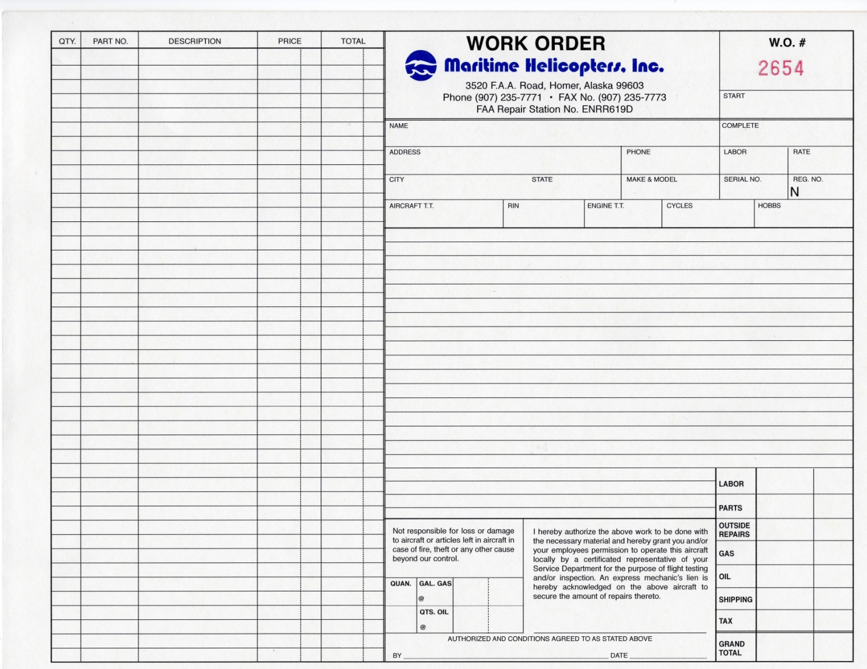
Form 002 07/01/2013
Instructions: Work Order Cover Sheet

This form shall be utilized to document the aircraft information and work to be performed. Complete the fields as follows:

Date W.O. Opened | Date the work order was opened
Customer Name | Customer’s name
Date W.O. Closed | Date the work order was closed
Address | Street address of company
Phone | Contact phone number
Labor | Total mechanic hours
Rate | Agreed upon shop rate
City & State | City & state of customer address
Make & Model | For example, 'Bell 407’
Serial # | For the aircraft, refer to the SOW. For an article, refer to the serviceability tag and enter the S/N of the aircraft from which the article was removed or the article’s S/N..
N# | For the aircraft, refer to the SOW. For an article, refer to the serviceability tag. Enter N# of the aircraft from which the article was removed.
Total Time | The total time for an aircraft. For an article, the aircraft’s total flight time at time of removal.
RIN | Fill in cycles, landings, or flights for articles or assembly (as applicable)
Engine TT | Total time of aircraft engine
Cycles / Starts | Engine/prop can be found on serviceability tag, status report, or logbook.
Hobbs | Total Hobbs tine from aircraft meter
Total Landings | For the aircraft and for an article, enter the total aircraft landings at time of removal (if applicable)

COMPONENTS

Name | Common abbreviations are acceptable (i.e., M/R, T/R, G/B, Assy, etc.)
Part # | Part number of the article from serviceability tag. If there are multiple articles, write "See below" and list the part numbers with each specific article in the Job Description.
Serial # | Serial number of the article from serviceability tag. If there are multiple articles, write "See below", list the serial numbers with each specific article in the job description.
Total Time/TSO | Applicable total time (since new) of the article or time since overhaul. If there are multiple articles, write “See below”, list the times with each specific article in the job description.

JOB DESCRIPTION

Item No. | For sequential itemization of different jobs (i.e. multiple articles: #1,#2,#3, etc.).
Description | Fill in the job description from the discrepancy on the Component record tag or an abbreviated version from the TSD or SOW for an aircraft. For more than one article, include the P/N, S/N, Name and applicable TSN/TSO times.

INSPECTIONS

Preliminary | A preliminary inspection MUST BE PERFORMED on any aircraft or article prior to maintenance being performed. Initials in this box stating an inspection was performed. If a preliminary discrepancy(s) was/were found, write up discrepancies(s) were found in box.
Hidden Damage | The QA inspector shall write up any hidden damage if found. If no hidden damage is found, write "N/A" for any hidden.
Continuity | QA Inspector initials. “See Attached” - continuity forms were used; “No” if continuity forms were not used.
Maintenance Final | Shall be initialed by the assigned Lead or Supervisor upon completion of work performed.
QA Final | The QA inspector shall acknowledge that the work order has had a final review prior to being closed and write in that statement.

MAINTENANCE RELEASE

Work Order No. | Write the work order number
Date | Enter the date the aircraft or article is returned to service
Signed | Authorized QA inspector signs prior to returning the aircraft or article to service.
Address | Fill in the appropriate address and CRS number of the MHI operated repair station returning the article to service.
FAA CRS # | Enter the CRS Number.

Vendor Audit – FORM MHI 003

Maritime Helicopters
Repair/Overhaul Vendor Audit Surveillance Report

Vendor Name: | Phone:  Fax:
Vendor Contact Name:
Address:

Key Company Officials:
Name | Title

Individual Responsible for Quality Control Program:
Name | Title | Phone

Type of Business: | Airline |  | Manufacturer |  | FAA Repair Station
Distributor/Supplier |  | Other |  |  | Repair Station #
Years in Business: |  |  |  | Number of Employees:

CAA or FAA Principal Maintenance Inspector:
Name | Phone

Major Customers:
Company Name | Service Provided

Personnel Numbers:
Production | Quality | Engineering |  |  | Certified Repairmen
 |  |  | Yes | No |  | N/A
1) Certification
a) Do you have a FAR Part 145 Repair Station Certificate?
i) Please attach a copy of the certificate and operations
specifications to this questionnaire.
b) Do you have an approved anti-drug program?
i) Please attach a copy of the FAA acceptance/exemption
letter.
c) Do you have an approved alcohol testing program?
i) Please attach a copy of the FAA acceptance/exemption
letter.
2) Quality Control Program
a) Do you have an established quality control program?
b) Is it described in detail in a quality control manual or other
appropriate document?
c) Please describe the functional separation of Quality
Control and Production.
d) Are all inspections and tests documented?
e) Are all incoming parts and materials subject to a
documented receiving inspection?
3) Technical Data
a) Do you have the required technical data on-hand to
perform the work we will be contracting/are sending to
you?
b) Do you have an established system to ensure technical data
remains current?
c) Is uncontrolled technical/reference data marked as such
and segregated from controlled data?
4) Tooling and Test Equipment
a) Do you have adequate tooling and test equipment
necessary to perform the work we will be contracting/are
sending to you?
b) Do you have an established system to ensure company and
personal tools and test equipment are maintained
serviceable/calibrated?

 | Yes | No | N/A
5) Training
a) Do you have a formal training program for all supervisors, inspectors, and technicians?
b) Do you document all training?
6) Facilities
a) Do you have adequate facilities to perform the work we
will be contracting/are sending to you?
b) Do you have a system that ensures parts, materials, and
customer property is protected from damage, theft, and
contamination?
c) Are non-aircraft related activities segregated from aircraft
related activities?
7) Work Processing
a) Do you have a system to properly identify customer parts
throughout all maintenance actions and while in storage?
b) Are serviceable and unserviceable units kept segregated?
c) Are scrap parts tagged and removed from the work area?
8) Stores
a) Do you have a system to ensure all parts and materials are
environmentally protected?
b) Do you maintain traceability certification for all parts and
materials?
c) Are aircraft parts segregated from non-aircraft parts?
d) Do you have a quarantine area for rejected parts and
materials awaiting disposition?
e) Are life limited scrap parts returned to the customer or
mutilated to prevent return to service?
f) Do you have a system that monitors shelf-life limited parts
and supplies?

Vendor Comments:

The data herein is applicable to the execution of contracts and the filling of orders from Maritime Helicopters, Inc. It is agreed that Maritime Helicopters, Inc. will be notified of any relocation or transfer of operations, or any change in quality control organization or procedures which affects compliance of relevant supplies and procedures to Maritime Helicopters, Inc. requirements. It is recognized that failure to furnish a description of such changes for Maritime Helicopters, Inc. review, or willful misrepresentation of any fact specified herein constitutes a material breach of contract which may result in disapproval as a Maritime Helicopters, Inc. vendor and void any existing contract purchase order.
Signature of Company Official | Position Title
Name | Phone

This Section for Maritime Helicopters, Inc. Use Only

Work Contracted/Intended:

Type Audit: | Initial | Recurrent | Follow-Up | Special

Corrective Action Required |  | Date Requested | Date Due: | Date Received:
Yes | No

Approved for Use: | Yes | No | By: | Date:
Approved Vendor List Updated:

Next Scheduled Audit Date:

Comments:

Records Accounting: | Completed Checklist |  | Finding/corrective Action Form(s)
Repair Station  Certificate |  | Operations  Specifications |  | Drug Letter | Alcohol Letter

Instructions: Vendor Audit Form

This form shall be utilized to document Maritime repair and overhaul vendors in performing a self audit.

Repairable Parts Tag – Form MHI 004

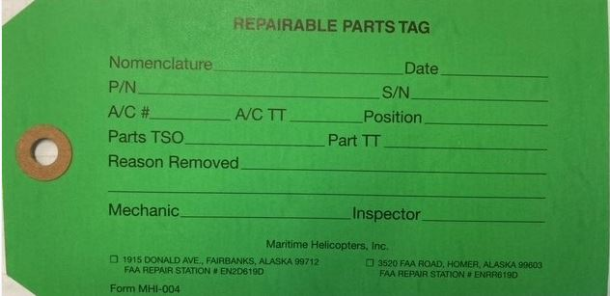

Instructions: Repairable Parts Tag

This tag shall be utilized to record the information of a repairable article. It is initiated by a mechanic. It will remain with the article until the article is rejected or made serviceable.

Part Name | Part name.
Date | Date of removal.
Part No. | Part number.
Serial No. | Part serial number.
Aircraft N# | Aircraft registration number.
Position | If multiple locations i.e., Left hand, Upper
TSO | Time Since Overhaul, If applicable.
Total Time | Total time of part.
Reason Removed | Why removed; Unserviceable, overhaul, etc.
Mechanic | Signature of mechanic that removed the part
Inspector | Name of approving inspector, if required.

Part 145 Work Sheet – FORM MHI 005
Sample: Maintenance Discrepancy and Work Record

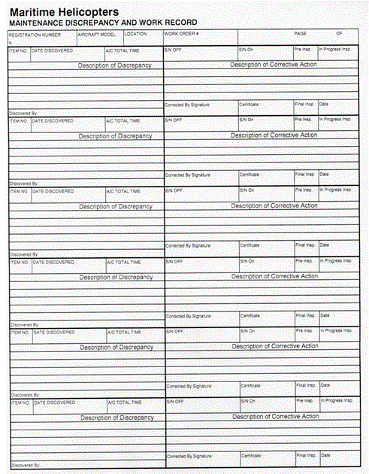

Instructions: Maintenance Discrepancy and Work Record

This form shall be utilized to document discrepancies and corrective actions. Upon completion, this form will become part of the work order package.

Aircraft No. | Enter aircraft registration number.
Aircraft Model | For example, 'Bell 407’
Location | Where maintenance is being performed at
Work Order No | Found at the top of the form 5087
Page No. | Page number if multiple pages are used.
Item # | Item # for sequential itemization of different tasks to be performed (i.e. for multiple steps: #1, #2, #3, etc.).
Date discovered | The person that entered the discrepancy must input date of the entry.
Acft TT | Aircraft total current airframe time
Description | Use this space to describe the removal or discrepancy.
Corrective Action | State the installation/corrective action within the section provided. References must satisfy requirements per CFR 14 § 43.13. i.e. MM, dwg, ICA.
Discovered by | Mechanic who found the discrepancy will enter their initials
Corrective by signature | The mechanic that entered the corrective action will enter their initials.
Certificate | Mechanics certificate number (may be Repair Station number)
Final Insp | QA inspector will enter their initials if all work has been completed satisfactorily.
In progress inspection | If item is being inspected as part of a larger assembly

Serviceable Parts Tag – FORM MHI 006

FRONT

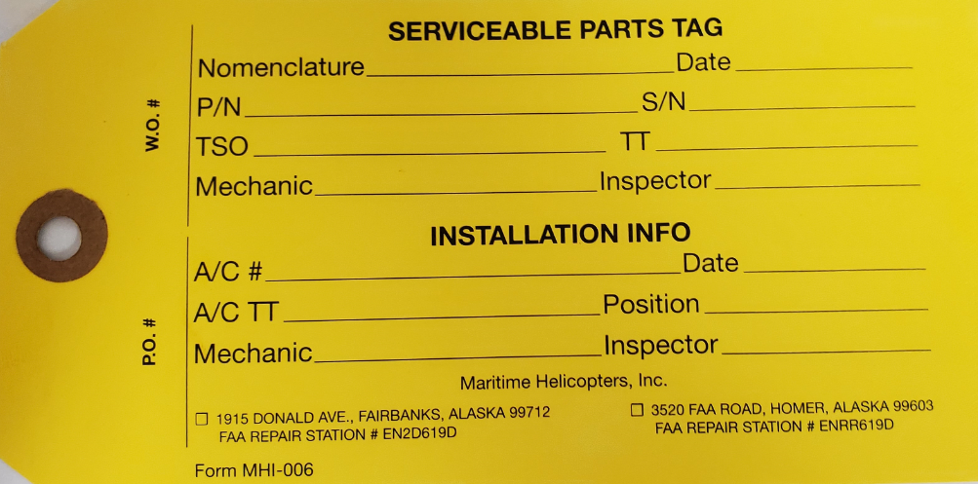

BACK

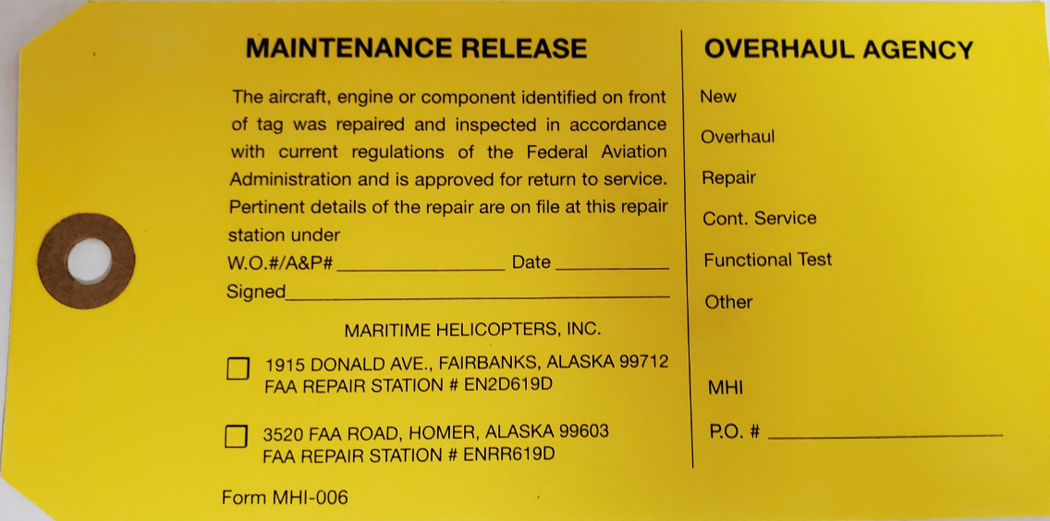

Instructions: Serviceable Parts Tag

This tag shall be utilized to record the information of a serviceable article. It is initiated by a mechanic. It will remain with the article is installed.

Nomenclature | Part name.
Date | Date of serviceability.
Part No. | Part number.
Serial No. | Part serial number.
TSO | Time Since Overhaul if applicable.
Total Time | Total time of part. Also enter a RIN count if applicable
Mechanic | Signature required of the mechanic removed the part.
Inspector | Signature required of the QA inspector or the mechanic condemning the part.
INSTALLATION INFO
Aircraft N# | Aircraft registration number.
Date | Date of installation.
Acft TT | Current aircraft airframe total time
Position | I.e. L/H, Upper, etc.
Mechanic | Installing mechanic name
Inspector | Installation Inspector
W.O # | Work Order number (if applicable)
Date | Date of Release.
Signed | Signature of releasing inspector
OVERHAUL AGENCY
 | Circle status of part. i.e., new, overhauled, repaired, etc.
MHI PO# | Enter MHI Purchase Order number

Rejected Part Tag – Form 007
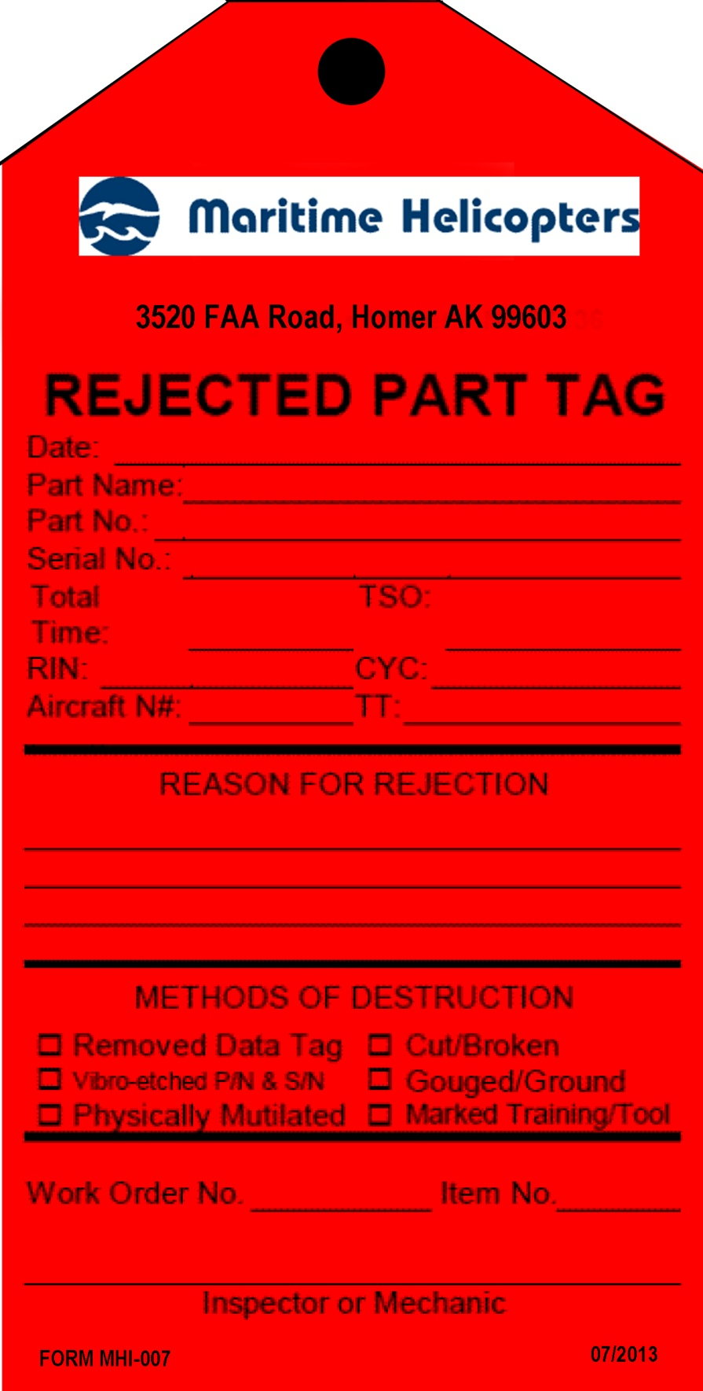

Instructions: Rejected Part Tag

This tag shall be utilized to record the information of a rejected article. It is initiated by a mechanic. It will remain with the article until the article is destroyed or mutilated.

Date | Date of rejection.
Part Name | Part name.
Part No. | Part number.
Serial No. | Part serial number.
Total Time | Total time of part.
TSO | If applicable.
RIN | If applicable.
CYC | If applicable.

Aircraft N# | Aircraft registration number.
TT | If applicable.
Reason | The reason for rejection must include a detailed explanation of why the part is not serviceable.
Methods Destruction | Record methods used to render the part un-usable. Prior to destruction, ensure parts are not to be returned to the owner.
Work Order No | Work order number.
Item No | Discrepancy item in the work order originally rejecting the part.
Inspector/Mech | Signature required of the QA inspector or the mechanic condemning the part.
Cert Type & No | Enter the applicable repair station number if signing for an HFS operated repair station.

Identification Tag - FORM MHI 008
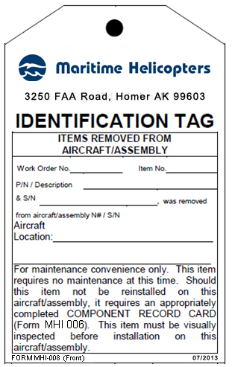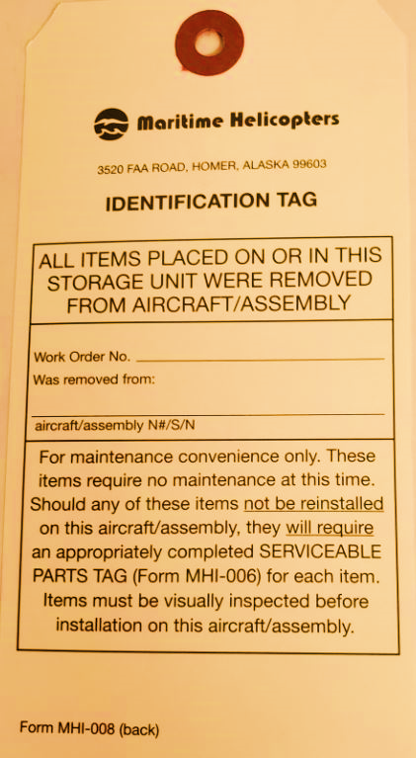

Instructions: White Identification Tags

This tag shall be utilized to identify articles or shelving/storage units as required. It is initiated by a mechanic. This tag may be discarded when the component(s) is reinstalled on the same aircraft or identification tag is replaced by a component record card (form MHI 006).

Work Order No. | Enter work order No. from applicable form MHI 002.
Item No. | Enter discrepancy item number from form MHI 005.
P/N Description | Enter part number of article and describe.
& S/N | Enter article serial number.
Removed from N#/S/N | Enter next higher assembly information.

Side One: ITEMS REMOVED FROM AIRCRAFT / ASSEMBLY

With the information on this side completed, the tag shall be attached to indicate a serviceable article’s removal from an aircraft "for maintenance convenience only”. This shall be attached to the individual item. Should the individual articles labeled with an "Identification Tag,” form MHI 008, require any maintenance, enter a work order discrepancy card entry on form MHI 005. If the removed article is not to be reinstalled on the original aircraft, it requires the article to be tagged with a component record tag (form MHI 006).
NOTE: No item removed and tagged with a white Identification Tag, form MHI 008 will be reinstalled unless the item is deemed “serviceable” by an appropriately rated mechanic.

Side Two: ALL ITEMS PLACED ON OR IN THIS STORAGE UNIT SIDE

With the information on this side completed, the tag shall be utilized to identify shelves, racks and containers.
In the case of cabin interiors (seats, upholstery, etc.), empennage or fuselage cowls, inspection/access panels, hardware, and other similar items, such parts must be serviceable and will be segregated on shelves, racks or in containers labeled as appropriate with one identification tag.

Receiving Inspection Log – FORM MHI 009

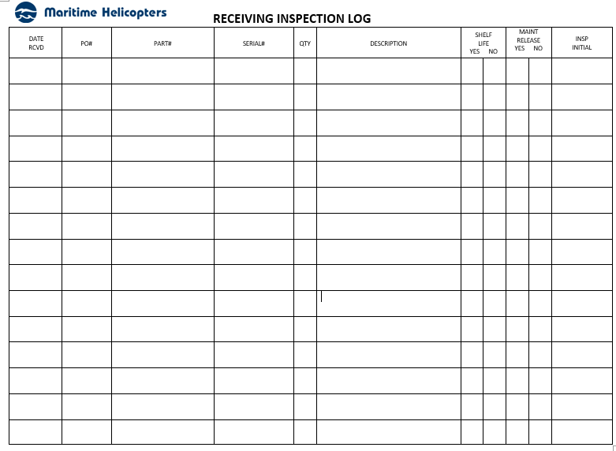

Instructions: Receiving Inspection Log

This form provides a record of articles received into the repair station. It is initiated by an incoming/receiving Inspector. The form is to be archived in the incoming and receiving area.

Date Received | Supplying vendor name as stated on invoice.
PO# | PO number as stated on invoice.
Part # | Number of part.
Serial # | Serial number affixed to part.
QTY | Total number of parts received as stated on invoice.
Description | As stated on invoice.
Shelf Life | Indicate YES or NO whether shelf life is limited.
Maint Release | Indicate YES or NO whether maintenance release was supplied with unit.
Insp Initial | Initials of incoming and receiving inspector completing the inspection.

Non-Destructive Testing Parts Tag – FORM MHI 010

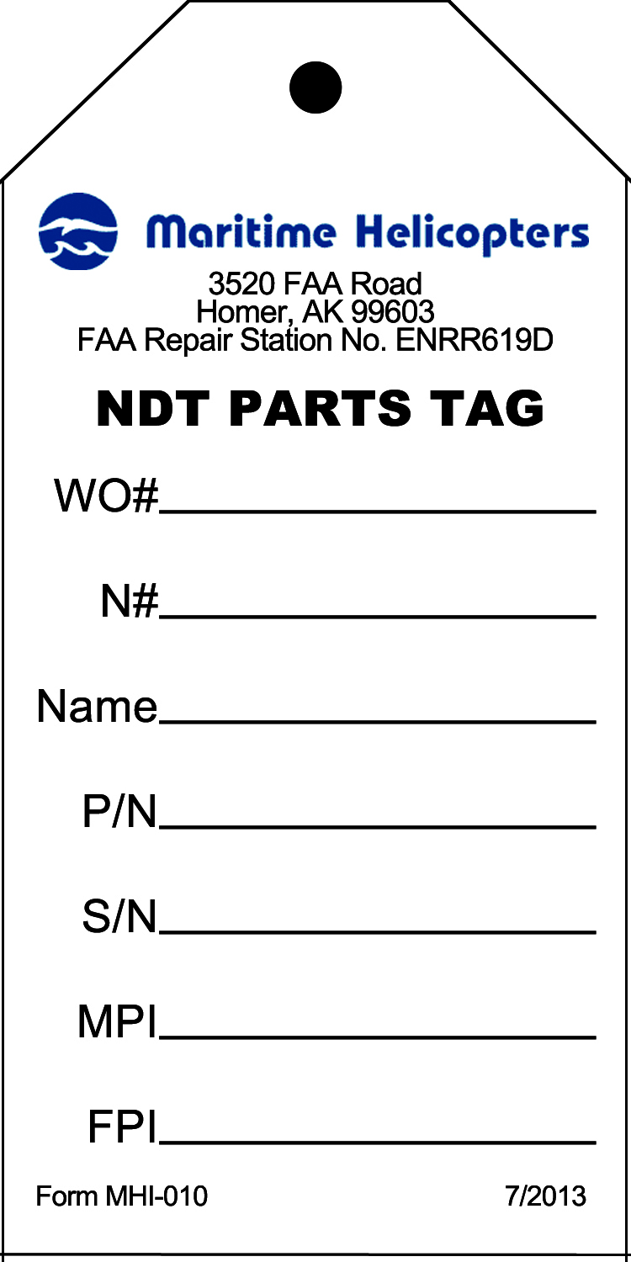

Instructions: Non-Destructive Testing Parts Tag

This tag is used to identify articles leaving an MHI repair station for non-destructive testing. It is initiated by a mechanic. After work is performed by the vendor this form is no longer required for the work order package.

WO # | Assigned work Order number from form MHI 002.
N# | Aircraft’s registration number.
Name | The given nomenclature/name of the article (i.e. “Sun Gear”).
P/N | Part number of the article.
S/N | Serial number of the article. If there is no serial number use “NA”.
MPI | X on line indicating if a magnetic particle inspection is required.
FPI | X on line indicating if a fluorescent penetrant inspection is required.

NDT Inventory Log – FORM MHI 011
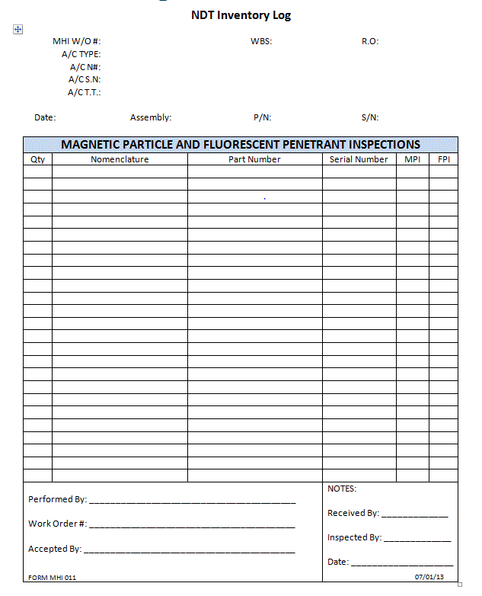

Instructions: Non-Destructive Testing (NDT) Inventory Log

This form is an inventory log of articles sent for non-destructive testing. It is initiated by a mechanic. It will be archived with the work order package.

Note: Leave no blanks – use ‘N/A’ if not required or not applicable.

W/O # | Work order number assigned on form MHI 002
A/C Type | Aircraft type (i.e. “Bell 407”).
A/C N# | Aircraft’s registration number.
A/C S/N | Aircraft’s serial number.
A/C T.T. | Aircraft’s total time.
Date | Date the form was initiated.
Assembly | Higher assembly’s nomenclature, if applicable (i.e. “Main Transmission”).
S/N | Serial number of the higher assembly, if applicable.
Qty | Number/quantity of pieces for the given article.
Nomenclature | Given nomenclature of the article (i.e. “Sun Gear”).
Part Number | Enter the part number of the article.
Serial Number | Enter the serial number of the article. If there no serial number, use “NSN” (“No Serial Number”).
MPI | “X” in the appropriate box if this type of inspection is required for the article.
FPI | “X” in the appropriate box if this type of inspection is required for the article.
Performed By | For vendor use only.
Work Order # | For vendor use only.
Accepted By | For vendor use only.
Notes | Use this space to note anything unusual or noteworthy. If no notes, enter “N/A”.
Received, Inspected By | Individual(s) receiving and inspecting the article must sign/date here.

Shelf Life Audit – FORM MHI 012

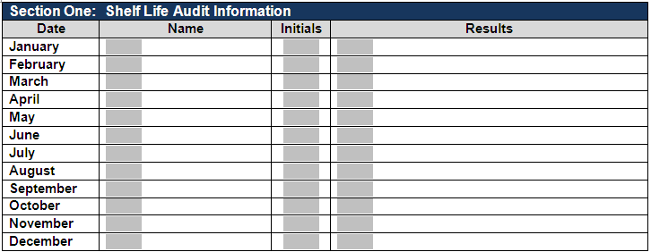

Instructions: Shelf Life Audit Sheet

This form documents that an audit of shelf life items in the storage unit was performed. It will be initiated by the person responsible for monitoring MHI operated repair station shelf life products. Shelf life audits are to be conducted by the end of each month. This form will be discarded upon initiation of a new, annual form.

Date | Day the audit is accomplished for the appropriate month.
Name | Printed name of individual performing the audit.
Initials | Individual’s initials.
Results | Brief description of results.

Inventory Part Receiving Label – FORM MHI 013 (Fairbanks Only)

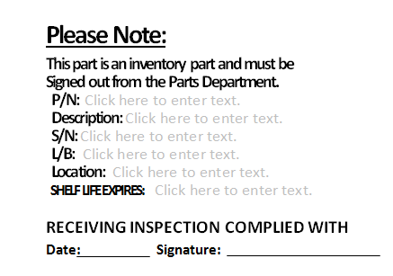

Instructions: Inventory Part Receiving Label

This form is placed in parts department after an incoming and receiving inspection has been performed.

P/N | Manufacturer Part Number
Description | Nomenclature of Part
S/N | Serial Number if one present
L/B | Lot or Batch Number
Location | What location on the parts shelf
Shelf Life Expiration Date | Enter date expires if item has a shelf life
Date | Date the incoming/receiving inspection performed
Signature | Signature of person performing the incoming/receiving inspection

Inventory Part Receiving Label – FORM MHI 014 (Homer Only)

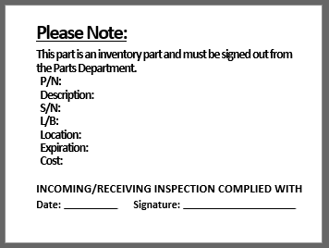

Instructions: Inventory Part Receiving Label

This form is placed in parts department after an incoming and receiving inspection has been performed.

P/N | Manufacturer Part Number
Description | Nomenclature of Part
S/N | Serial Number if one present
L/B | Lot or Batch Number
Location | What location on the parts shelf
Expiration | Enter date expires if item has a shelf life
Cost | Optional
Date | Date the incoming/receiving inspection performed
Signature | Signature of person performing the incoming/receiving inspection

Summary of Employment – FORM MHI 015

Name: _____________________________________________________________

Scope of Assignment: Maritime Helicopters Maintenance

Present Title: ________________________________________________________

Years’ experience in this type work: ______________________________________

Past employment record: (at least 5 years)

From: | To: | Place: | Type of Work | Position

Authorized to sign: All Inspections & Maintenance per MHI Inspection Procedures Manual

Type and number of FAA Certificate(s) now held:

1. ____________________________________________________________________________

2. ____________________________________________________________________________

3. ____________________________________________________________________________

Instructions: Summary of Employment

This form shall be utilized to capture information required by Title 14 CFR §145.161(a)(4) for management, supervisory, inspection, and return to service personnel. For all other repair station positions, this is optional. This shall be maintained by the Chief Inspector during the individual’s period of employment.

Employee Name | Name
Scope | Define scope of present employment.
Employee Title | Title
Experience | Number of years in this type of work
Past Employment | Enter past 5 years of experience
Dates of Employ | Dates of previous employment
Type of Mait Performed | Types of maintenance work performed (attach add ’l sheets)
Type FAA Certification | FAA Certificates currently held (A&P, IA, Repairman, etc.)
Cert Number | Certification Numbers

Calibration Sticker (sample) – FORM MHI 016

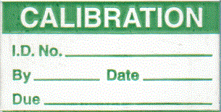

Instructions: Calibration Sticker

This is used as a replacement sticker on a calibrated tool in the event the original sticker is lost or damaged. The wording and size of information might vary in order to fit the necessary information on the sticker and too. This sticker is to remain on the calibrated tool until the tool is recalibrated.

ID Number Enter I.D. No. of the tool (Either model number or S/N)

By Initials of person performing the calibration

Date Enter date of calibration

Date due Enter tool re-calibration due date

Capabilities Self Evaluation Checklist – FORM 017
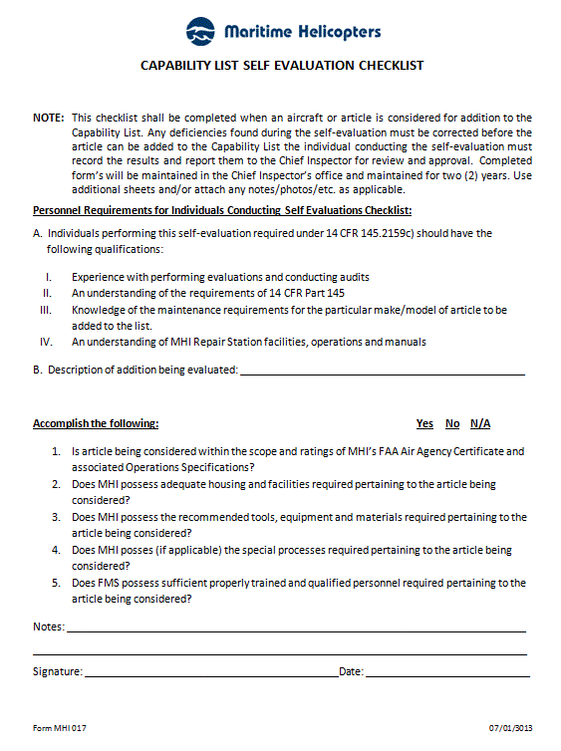

Instructions: Capabilities Self Evaluation Checklist

This form shall be utilized for the purposes of performing a self-evaluation prior to modifying the Repair Station Capabilities List. This self-evaluation shall also be utilized for the purpose of performing an annual review of the capabilities. Attachments may be utilized if needed for additional information.

Evaluation is to Indicate the nature of the Self Evaluation (Add, Delete, modify an existing capability, or perform an Annual Review).

Manufacture Self Explanatory

Model Number Enter manufactures model number. If there is no model number then enter N/A.

Part Name Enter the manufacturers name for the part or assembly. If capability is not part number specific then enter N/A.

Part Number Enter the manufactures’ specific part or assembly number. If capability is not part number specific then enter N/A.

Capability to Enter the applicable Capability to be performed
be Performed

FAA Ratings Enter the applicable FAA Ratings that are affected by this evaluation.
Affected

Manufacturers The documentation required per CFR §145.109(d) shall be verified as accessible and
Documentation current. The required manufactures manuals shall be entered within the chart once
verified. Access to manufactures Service Bulletins (SB) and FAA Airworthiness
Directives (AD) once verified shall be entered into chart. This entry need not list each
individual SB or AD but may be entered as a single line entry such as "Bell Helicopter
Canada BH-407 Service Bulletins" or "FAA Airworthiness Directives"

Manual Review Perform a review of the Repair Station Manual System and verify if this request requires any revisions to be made. Any revisions required must be in place prior to
performing the requested functions. Indicate YeslNo.

Equipment, Tools, The required manufactures tooling, equipment and materials shall be verified as
Materials, Facilities, onsite or readily accessible. If equivalent tooling is to be utilized, It must have an
And Processes equivalency evaluation performed prior. Calibration requirements must be verified as current. Verify if adequate facilities are available per CFR §145.103. Verify if any Special Processes are required, and if so does the repair station have the
ability to either perform those processes or have it complied with by an outside entity. Indicate YeslNo.

Trained Personnel/ Verify if there is adequately trained maintenance, inspection, and supervisory
Supervisory Staff personnel available. Verification may include: documented training, OJT, or experience. All trained individuals or supervisors are not required to be entered on the chart, only the minimum needed to perform the capabilities requested.

Approvals/Denials Check as applicable: Approved, Deleted, Annual Review Completed, or Denied.

Approval Upon review of the findings of this evaluation checklist, the Part 145 Accountable Manager and the Chief Inspector, or their designee, shall sign.

Tool Calibration Record – MHI Form 018

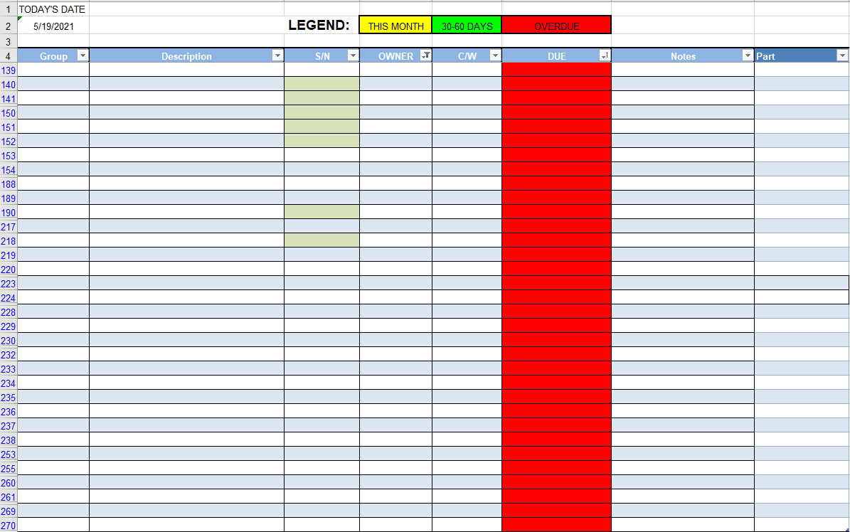

Instructions: Tool Calibration Record

This is used as a replacement sticker on a calibrated tool in the event the original sticker is lost or damaged. The wording and size of information might vary in order to fit the necessary information on the sticker and too. This sticker is to remain on the calibrated tool until the tool is recalibrated.

Group Enter the application
Description Enter the name of the tool
S/N Enter serial number of the tool
Owner Enter company or mechanic’s name
C/W Enter date tool was inspected
Due Enter tool re-calibration due date
Notes Enter relevant notes on status of tool
Part Enter what FAR or Personal the tool belongs to

Inventory Sign Out Tag – Form MHI 019

Required Logbook Entries Tag – Form MHI 020

Mechanic Signature/Initial Roster - Form MHI 021
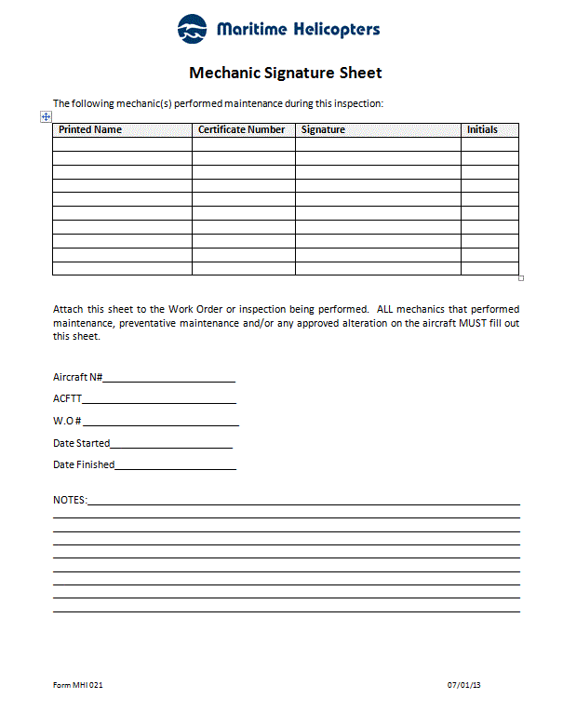

Altimeter 24 Month Checklist Form MHI 022
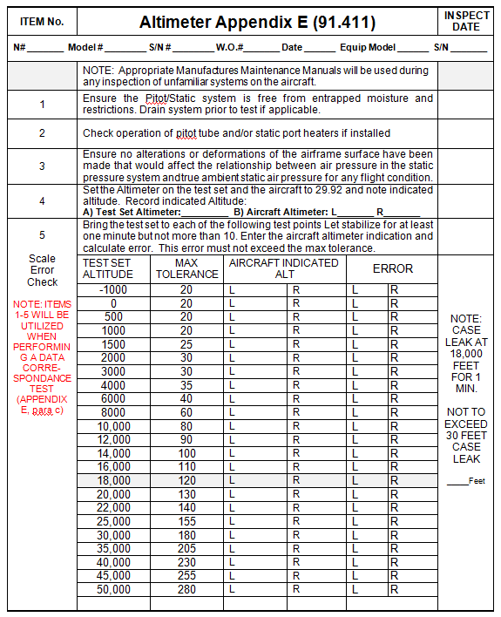

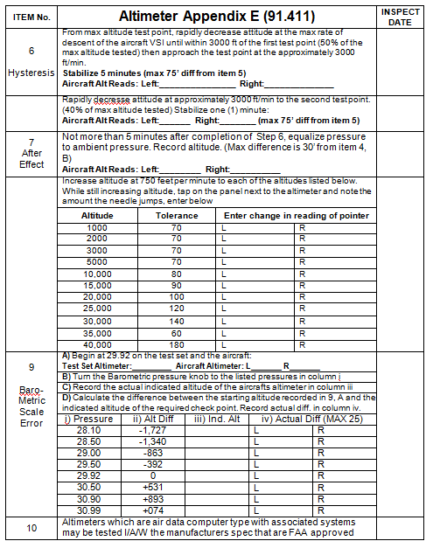

Transponder 24 Month Checklist Form MHI 023

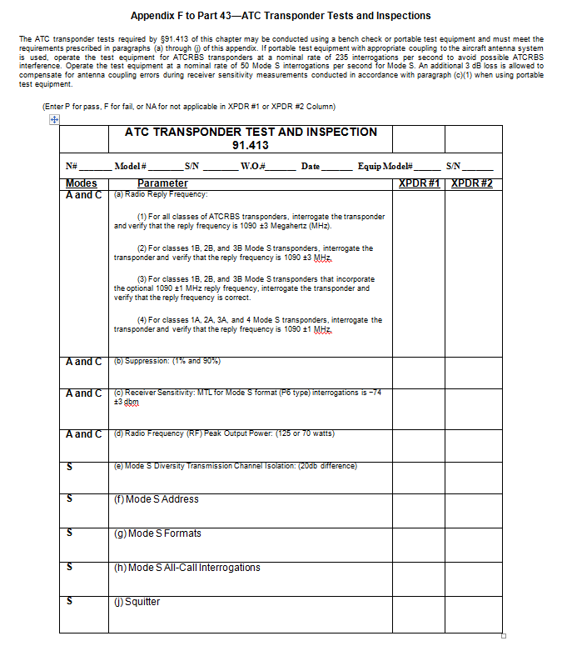

Repair Station Inspection and Return to Service Roster - Form MHI 024

Inspection/Return to Service Roster
Homer and Fairbanks Part 145 Repairs Stations
CFR 145.161(a)(2,3)
MHI 024

NAME | TITLE | APPROVALS | CERT # | DATE  AUTHORIZED

Repair Station Management and Supervisory Roster - Form MHI 025

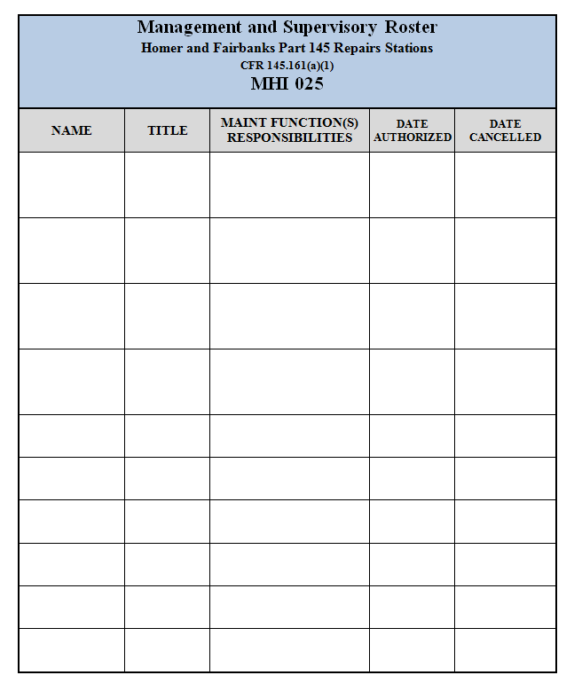

Reserved

TRAINING FORMS

Training Activity Report Form TR- 001

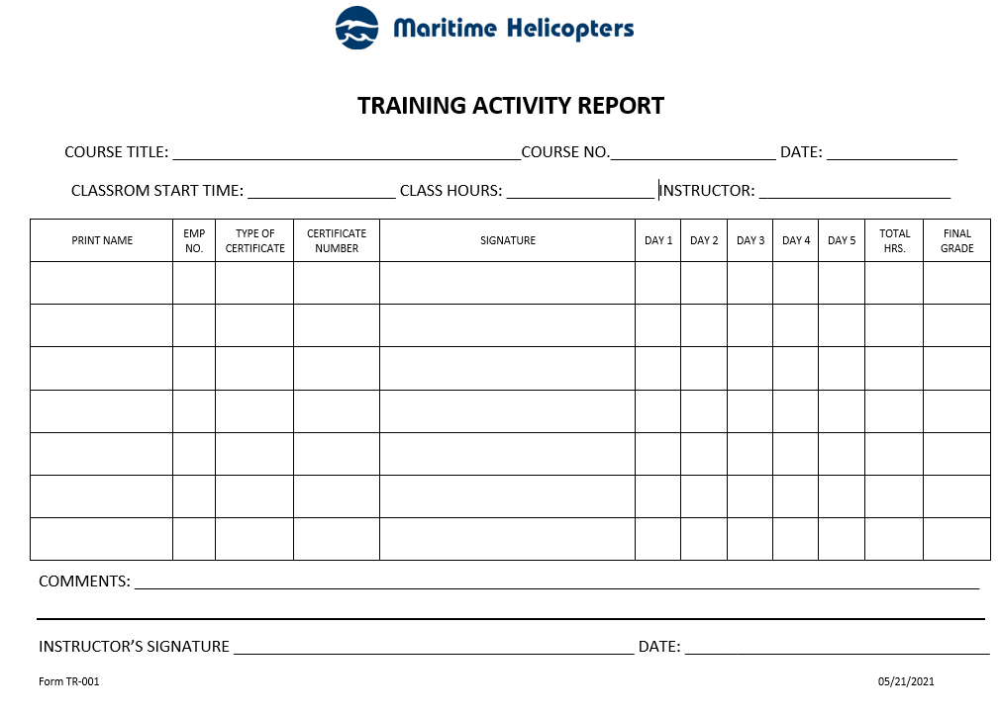
Instructions for completion of Training Activity Report Form TR-001:

1. COURSE TITLE: Title of Course for the activity report.
2. COURSE No: Assigned Course number.
3. DATE: Date of the activity report / date of course.
4. CLASSROOM START TIME: Course beginning time.
5. CLASS HOURS: Hours of course attendance.
6. INSTRUCTOR: Name of Instructor/s.
7. PRINT NAME: Name of course attendee.
8. EMPLOYEE NUMBER: Attendees employee numbers.
9. TYPE OF CERTIFICATE: TBA
10. CERTIFICATE NUMBER: TBA
11. SIGNATURE: Attendees signature.
12. DAY 1 through DAY 5: Hours of course attendance.
13. TOTAL HOURS: Total hours for the 5-day period.
14. FINAL GRADE: Grade awarded.
15. COMMENTS: Instructors comments on class.
16. INSTRUCTOR’S SIGNATURE: Signature of instructor.
17. DATE: Date of course completion.

Training Verification - Form TR-002

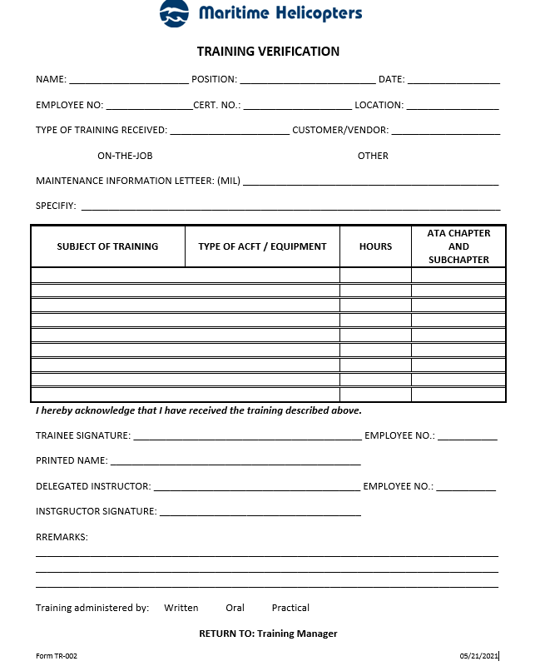

Instructions for completion of Training Verification Form TR-002:

1. NAME: Full name of trainee.
2. POSITION: Trainees employment position.
3. DATE: Date of completion of the Training Verification.
4. EMPLOYEE NO.: Employees MHI employment number.
5. CERT. NO.: Employees certificate number, if any.
6. LOCATION: Location where the training took place.
7. TYPE OF TRAINING RECEIVED: Initial / Re-current
8. CUSTOMER: Customer provided training – check box.
9. ON-THE-JOB: OJT training – check box.
10. OTHER: Check box and specify in either 11 or 12.
11. MAINTENANCE INFORMATION LETTER: (MIL) as issued by MHI.
12. SPECIFY: If 10 is checked, specify type of training received.
13. SUBJECT OF TRAINING/ TYPE OF ACFT/ EQUIPMENT: Course name / aircraft /equipment type for training received.
14. HOURS: Course/Training hours expended.
15. ATA CHAPTER AND SUBCHAPTER: ATA chapter and sub chapter content for the course, if applicable.
16. TRAINEE SIGNATURE: Signature of trainee receiving the course.
17. EMPLOYEE NO.: Employee Number of trainee receiving the course.
18. PRINTED NAME: Printed Name of trainee receiving the course.
19. DELEGATED INSTRUCTOR: Print Instructors Name.
20. EMPLOYEE NO.: Instructors MHI employee number, if applicable.
21. INSTRUCTOR SIGNATURE: Instructors signature.
22. REMARKS: Any remarks regarding the course – to be filled out by the instructor.
23. TRAINING ADMINISTERED BY: Check type of instruction technique employed for the course.

Employee Skill Survey - Form TR-003
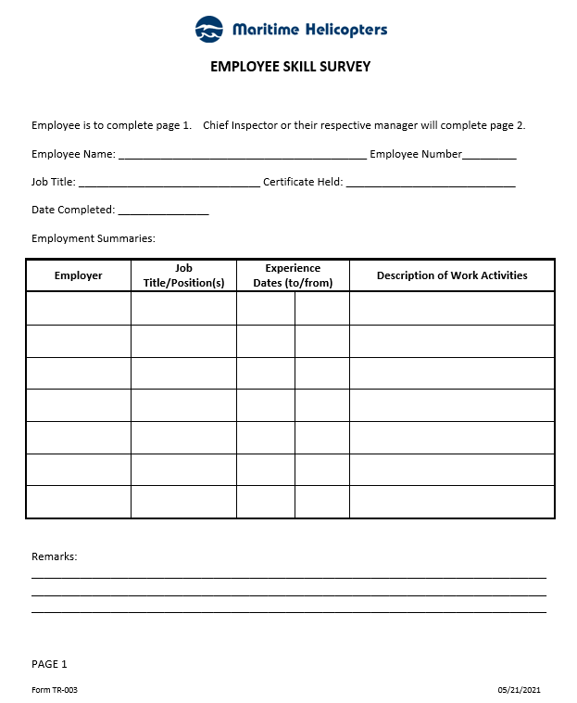

Instructions for completion of Employee Skill Survey Form TR-003:

1. Employee’s name (i.e. John Jet, etc.)
2. MHI employee number
3. Present job title/position (i.e. AMT, Lead, Inspector, etc.)
4. Type and number of 14 CFR Part 65 Certificate held (i.e. A&P 12345678, Repairman 1234567, etc.)
5. Date that employee completed page 1 of form
6. Provide name of employer (i.e. ABC Airlines, XYZ Repair Station, etc.)
7. Provide job title/position(s) held regarding employment (use multiple lines if required)
8. Enter beginning date of employment for positions held
9. Enter ending date of employment for positions held
10. Describe work activities conducted for relevant positions
11. Enter any additional details pertaining to work activities conducted, relevant experience, specialized skills or training that will assist evaluator in determining employee skill-set and overall experience level
12. Name of individual conducting skill survey evaluation
13. MHI employee number of individual conducting skill survey evaluation
14. Indicate if oral interview is required by selecting the appropriate box (i.e. √ or X) Yes or No
15. Indicate if oral interview was conducted by selecting the appropriate box (i.e. √ or X) Yes or No
16. If oral conducted, enter date
17. Check box (i.e. √ or X) to indicate that employee’s training records have been reviewed
18. Enter date that employee’s training record was reviewed
19. Evaluator will enter comments pertaining to evaluation (i.e. employee demonstrates a thorough knowledge of BHT 407, AS350 aircraft for both avionics and system maintenance, etc.)
20. Evaluator will check appropriate box (i.e. √ or X) to indicate if employee is of Minimal, Intermediate, or Advanced skill level
21. Evaluator will select appropriate box (i.e. √ or X) Yes or No to indicate if employee requires further training
22. Evaluator will provide details of training recommendation(s) (i.e. Employee will require a BHT 407 General Familiarization class, etc.)

Repair Station Needs Assessment - Form TR-004
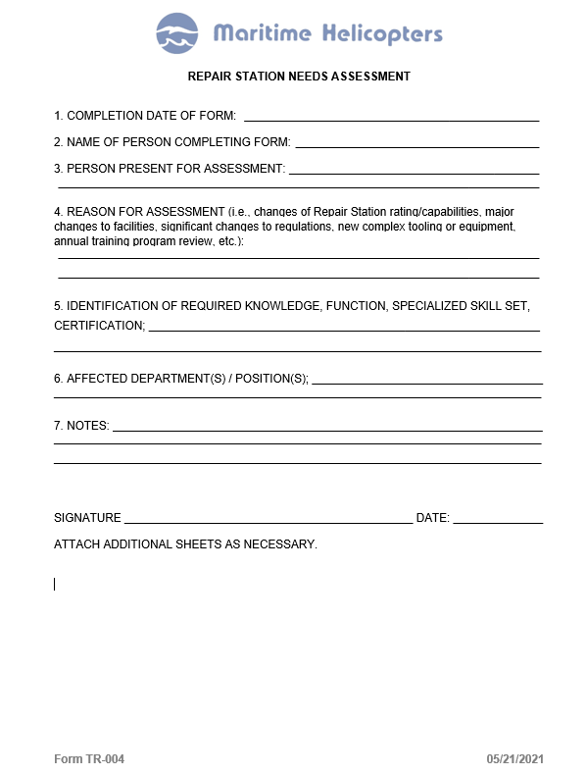

Instructions for completion of Repair Station Needs Assessment Form TR-004:

1. Date form completed.
2. Name of person preparing the form.
3. Individuals present for the assessment.
4. Enter applicable reason for assessment from item 4. If form is being completed for training program annual review, place Annual Review in this field.
5. Insert applicable criteria, (i.e. person performing maintenance, preventative maintenance and /or alteration/inspection functions, skills, experience and training of current employees, assessments of employees being assigned new tasks, return of employee to tasks after extended period, introduction of new regulations, procedures, equipment and record keeping procedures or an upcoming change in nature of basic repair station capability).
6. Departments and positions affected.
7. Add notes as/if required to further document pertinent details discussed during the assessment process including any assigned actions or items requiring further follow-up.
8. Signature of Chief Inspector or his/her designee.
9. Date of signature by Chief Inspector or his/her designee.

Course Evaluation - Form TR-005
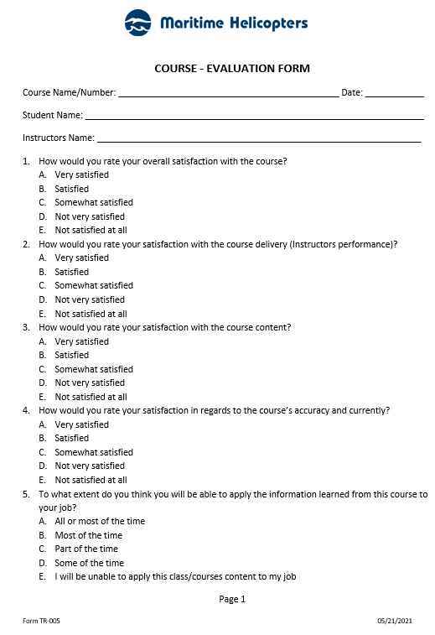

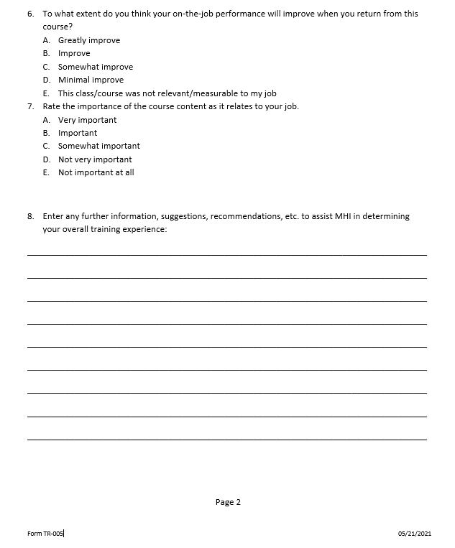

Instructions for completion of Course-Evaluation (Form TR-005) entries:

1. Enter Course Name or Number.
2. Enter Date of the course completion.
3. Enter Name of the Student completing the evaluation form.
4. Enter Name of the Instructor giving the course.
5. Answer all questions and circle the relevant answer letter.
6. Enter any notes or other information to assist MHI in determining your overall training experience

