

Homer Main Repair Station
Homer Municipal Airport
3520 FAA Road
Homer, AK 99603

Fairbanks Satellite Repair Station
Metro Field
1915 Donaldson Ave.
Fairbanks, AK 99701

REPAIR STATION
TRAINING PROGRAM MANUAL

CRS # ENRR619D
CRS # EN2D619D

Revision 3
07/01/21

Published by:
Maritime Helicopters, Inc.
3520 FAA Road
Homer, AK 99603
(907) 235-7771

Copyright © 2013 Maritime Helicopters, Inc.
All Rights Reserved. No part of the contents of this document may be reproduced or transmitted in any form by any means without the written permission of Maritime Helicopters, Inc.

Record of Revisions

This manual will be revised in accordance with Chapter 2 of this manual.
Rev No. | Rev Date | Change Summary
ORG | 11/01/13 | Original Issue
1 | 11/30/14 | Cover Page
2 | 11/15/15 | Page 6-1
3 | 07/01/21 | i, iii thru 9-1, 11-1 thru 11-12

List of Effective Pages

PAGE | REV | DATE |  | PAGE | REV | DATE |  | PAGE | REV | DATE
i | 3 | 07/01/21 |  | 11-5 | 3 | 07/01/21
ii | ORG | 11/01/13 |  | 11-6 | 3 | 07/01/21
iii | 3 | 07/01/21 |  | 11-8 | 3 | 07/01/21
iv | 3 | 07/01/21 |  | 11-9 | 3 | 07/01/21
1-1 | 3 | 07/01/21 |  | 11-10 | 3 | 07/01/21
2-1 | 3 | 07/01/21 |  | 11-11 | 3 | 07/01/21
2-2 | 3 | 07/01/21 |  | 11-12 | 3 | 07/01/21
3-1 | 3 | 07/01/21
3-2 | 3 | 07/01/21
3-3 | 3 | 07/01/21
3-4 | 3 | 07/01/21
4-1 | 3 | 07/01/21
4-2 | 3 | 07/01/21
5-1 | 3 | 07/01/21
5-2 | 3 | 07/01/21
5-3 | 3 | 07/01/21
6-1 | 3 | 07/01/21
7-1 | 3 | 07/01/21
7-2 | 3 | 07/01/21
8-1 | 3 | 07/01/21
9-1 | 3 | 07/01/21
10-1 | ORG | 11/01/13
11-1 | 3 | 07/01/21
11-2 | 3 | 07/01/21
11-4 | 3 | 07/01/21

_________________________________________ _________________________________________
FAA PRINCIPAL MAINTENANCE INSPECTOR FAA PRINCIPAL AVIONICS INSPECTOR

Table of Contents

1 Introduction 1-1
2 Manual Revisions 2-1
2.1 Manual Revisions and Control 2-1
2.2 Manual Approval Process 2-1
2.3 Revision Distribution 2-2
3 NEEDS ASSESSMENT 3-1
3.1 General 3-1
3.2 Overall Training Needs Assessment 3-1
3.3 Individual Needs Assessment 3-2
3.4 Changes to Repair Station Work Scope 3-3
3.5 Annual Training Program Review 3-3
4 COURSE DEFINITION 4-1
4.1 Course/Lesson Development 4-1
4.2 Initial Training 4-1
4.3 Hazmat 4-2
4.4 Recurrent Training 4-2
4.5 Specialized Training 4-2
4.6 Remedial Training 4-2
5 SELECTION OF TRAINING METHODS AND SOURCES 5-1
5.1 Training Methods 5-1
5.2 Training Sources 5-1
5.3 Training Instructor Evaluation 5-1
5.4 Observation 5-2
5.5 On-the-Job Training (OJT) 5-2
6 TRAINING DOCUMENTATION 6-1
6.1 Training Documentation 6-1
6.2 Training Records 6-1
6.3 Training Forms 6-1
7 MEASUREMENT OF TRAINING EFFECTIVENESS 7-1
7.1 Training Effectiveness 7-1
8 WORK PERFORMED FOR 14 CFR PART 91, 121, AND PART 135 OPERATORS 8-1
8.1 General 8-1
9 WORK PERFORMED BY INTERIM MAINTENANCE EMPLOYEES 9-1
9.1 Interim Maintenance Employess 9-1
10 MHI MAINTENANCE EMPLOYEES TRAINING CURRICULUM 10-1
10.1 Maintenance Employees Training Curriculum 10-1
11 APPENDIX A 11-1
11.1 Training Forms 11-1

Introduction
The Repair Station Training Program Manual (RSTPM) has been prepared in accordance with the current Title 14 CFR §145, FAA Advisory Circular AC 145-10, and the policies and procedures used at Maritime Helicopters, Inc. (MHI). This manual explains the MHI Training Program in detail. This training program manual contains the policies and procedures MHI uses to determine its training requirements and to develop its training program. The training program ensures that MHI employees, as required by 14 CFR §145.163(b), have the knowledge and skills to capably perform assigned task. MHI controls this manual in accordance with the procedures outlined in Chapter 2 of this manual. Employees are identified, training standards are established, training is provided, and the training program is revised as necessary.
A current copy of this RSTPM, including the associated RSM, QCM and RSFM, shall be accessible to applicable Repair Station personnel. A current copy of the required RSTPM and any revisions made will also be provided by electronic copy to the FAA Certificate Holding District Office (CHDO).

Manual Revisions
The Accountable Manager oversees the creation and revision of MHI controlled documents. Department Managers and Supervisors may submit suggestions and corrections for incorporation into this manual by contacting the Training Manager. Changes made to this manual will be summarized in the change summary table and indicated throughout the manual by change bars. A vertical bar (change bar) in the right margin indicates a change, addition, or deletion in the adjacent text for the current revision of that page only. The change bar is dropped at the next revision of that page. The effected pages will also be annotated by updating the revision level and date in the top right-hand corner. The list of effective pages will also be updated.

Manual Revisions and Control

The Chief Inspector is responsible for the content, currency, completeness, and revisions of this manual. Review of this manual will be conducted annually in conjunction the Training Program Review as outlined in Chapter 3.5 of this manual. This manual requires FAA approval prior to release. Revisions to this manual must be routed for MHI internal and FAA approval prior to distribution. This manual cannot be published to end users prior to formal submission to and approval by the FAA.

Manual Approval Process

The MHI Repair Station Training Program Manual (RSTPM) is an FAA-approved manual, no changes or revisions will be made without prior FAA approval.

Approval of the RSTPM is a two-part process involving an initial approval by MHI for the proposed revision, then a presentation to the CHDO for FAA approval. Once FAA approval has been obtained, the manual revision will be published to the MHI Maintenance Portal.

The Chief Inspector or the Part 145 Accountable Manager will approve each page of the manual and revisions thereof. FAA approval of the manual shall be indicated on the List of Effective Pages (LOEP) by the placement of a signature at the bottom of page of the LOEP in the preformatted area. Upon review and MHI approval, the Chief Inspector or his/her designee will submit a copy of the proposed revision to the cognizant CHDO assigned Principal Inspector (PI) for review and Administrator approval (see paragraph below of this section regarding the RSTPM revision process).

If the proposed revision is approved by the CHDO, the LOEP will signed and dated (or stamped) and returned to MHI via e-mail.

If a proposed revision is rejected by the CHDO, an email indicating the date, manual, or revision number of the manual being rejected will be generated. The proposed revision will be returned to MHI with an explanation of discrepancies that must be addressed (the CHDO may retain a file copy of the revision at their discretion).

The non-compliant portion(s) of the revision will be addressed by MHI and resubmitted to the CHDO. This process will be repeated as necessary until FAA approval is obtained. As needed, the Chief Inspector will make contact with the CHDO either by phone, or schedule an in- person meeting to discuss the details of non-compliant portions. This will ensure the MHI RSTPM is compliant with applicable FAA guidance materials (i.e., CFR’s, FAA Orders, etc.).

Revision Distribution

Once the manual revision is approved a signed copy shall be posted to the MHI Maintenance Portal. Each revision shall be forwarded to the CHDO by electronic format to the FAA inspectors who will then either accept or reject the manual revision. The FAA inspector will inform the repair station of acceptance or rejection by e-mail. The e-mail will address the manual title, manual date, and revision number. If the manual is rejected, the FAA inspector will provide a detailed explanation of the deficiencies and advise the repair station.

NEEDS ASSESSMENT
A training needs assessment, MHI Form TR-004 is used to identify MHI’s overall training needs and individual employee training needs. It is method for defining areas of study and/or courses/lessons made available to employees and for identifying training sources and methods available to employees for the areas of study, courses, and/or lessons. The needs assessment is used in documenting employee qualifications and training and used to measure the effectiveness of the training program and to make changes as necessary.

General

Persons performing maintenance, preventive maintenance, alterations or inspection functions must be assessed and trained in accordance with the Federal Aviation Administration (FAA) approved procedures set forth in this manual. All other employees may be trained in accordance with the approved procedures of this manual at management discretion. MHI has established an Initial training program that includes indoctrination subjects. The training program also includes recurrent, specialized, and remedial training areas of study for its required employees. MHI develops areas of study for the following staffing categories:

Technicians and other individuals performing maintenance, preventive maintenance, alterations or inspection functions such as:
- Inspectors;
- Leads;
- Mechanics.

MHI utilizes MHI Employee Skill Survey (MHI Form TR-003) to assess an individual’s skill set.

Overall Training Needs Assessment

To determine MHI’s overall training requirements, the Chief Inspector and Part 145 Accountable Manager will review MHI’s Operations Specifications (OPS); current Capability List; job position duties and responsibilities listed in Chapter 3 of the RSM; procedures in the QCM, customer/operator requirements; and current and expected customer work-scope activity. This will provide a general outline and description of skills, knowledge and expertise that MHI and its employees should possess. This assessment will include areas including but not limited to the following:
- 14 CFR Part 145 operations and procedures;
- 14 CFR Part 91, 135, & 121 maintenance handling;
- Aircraft maintenance, troubleshooting, handling;
- Aircraft avionics systems, maintenance and handling;
- Awareness of electrostatic discharge (ESD);
- Inspection of aircraft, articles, components;
- Returning aircraft and articles to service;
- Receipt and handling of aircraft materials and components thereof;
- Usage of technical data;
- Human factors in aircraft maintenance;
- Hazardous Material handling;
- Specialized Services.

The Chief Inspector or his/her designee will complete MHI Repair Station Needs Assessment, Form TR-004, for this process. This form will be maintained electronically by the Chief Inspector.

MHI continuously evaluates its overall repair station training needs. However, MHI will specifically revise the training program when:
- It identifies additional training needs;
- Changes to its ratings, capabilities, facilities, equipment, or work scope require additional training areas, classes, or lessons;
- Significant changes to industry standards or regulations occur;
- New complex tooling or equipment is obtained;
- New models/types of aircraft in which MHI will maintain or alter.

Individual Needs Assessment

MHI employees will then be assessed against the established requirements and specific needs for the position and tasks assigned as required. If it is determined that an employee does not possess the capability to perform the maintenance, preventive maintenance, or alterations, and inspection functions, appropriate training will be administered in accordance with the procedures in this manual.

MHI uses Employee Skill Survey, Form TR-003 to evaluate an individual and determine his/her previous work experience, knowledge, and skill set.

This allows MHI to establish the employee’s capability to properly perform the assigned tasks. The results of this determination are compared with the need(s) established on MHI Repair Station Needs Assessment, Form TR-004, and any required training shall be conducted.

A resume may be provided in lieu of completing page 1 of Form TR-003 so long as it contains all required details of the Employee Skill Survey, Form TR-003, however page 2 must still be completed.

NOTE: An oral interview may also be required to ensure a thorough understanding of the individual’s previous work experience, knowledge, and skill set. This oral interview will be accomplished by the appropriate departmental head or his/her designee.

NOTE: The preferred method of demonstrating past training is through copies of certificates, transcripts, diplomas, military training completion, etc.

Whenever MHI hires a new employee or transfers an employee to a new job position, the Chief Inspector and/or Part 145 Accountable Manager will utilize the Individual Needs Assessment process to assess the individual’s skill level and qualifications against the requirements for the assigned functions or tasks. The Chief Inspector and/or Part 145 Accountable Manager will determine if/what training is necessary, and ensure the individual receives the necessary training in the appropriate timeframe.

Training is documented in accordance with Chapter 5 of this manual. The MHI Employee Skill Survey, Form TR-003, (and/or an equivalent resume when used in lieu of page 1 of Form TR-004) will be placed in the employee’s digital training file.

During identification of overall training needs, MHI will consider items including, but not limited to the following:
- The tasks associated with each person responsible for performing maintenance, inspection and preventive maintenance;
- The skills, experience, and training of new and/or current employees;
- How assessments will be made of employee being assigned new tasks;
- The return of an employee to tasks after an extended period;
- The introduction to the employee of new regulations, procedures, equipment, or recordkeeping requirements;
- Preparing personnel for a change in the nature of basic repair station capability.

Changes to Repair Station Work Scope

Whenever MHI is planning to change its facilities, equipment, or scope of work as reflected in its OPS’s or Capability List, it will conduct a review of its current training program. The need for additional training will be based on an analysis of the new work to be performed, the capability of employees, and the availability of in-house training.

Appropriate changes will be made to initial, recurrent, and specialized training areas of study, including existing courses or the addition of new courses, positions, and individuals requiring the training, and when the new training needs to be implemented and completed.

Annual Training Program Review

The Chief Inspector and Part 145 Accountable Manager will complete an annual review of the training program and will establish if any changes are warranted. This process will require the completion and review of the Repair Station Needs Assessment, Form TR-004. “Annual Review” will be placed in the Reason for Assessment section. In addition, a review of observations, examination results, and feedback from the Measurement of Training Effectiveness process (see Chapter 7 of this manual) will be considered.

The results of the review will be notated in the Notes section of the MHI Form TR-004, including any recommendations.

The Chief Inspector will consult with the other MHI departmental heads and the Accountable Manager to determine the impact of required changes, and make necessary adjustments if/when required.

As a part of this annual review, MHI will analyze employee roles and responsibilities, employee experience levels, and the method of delivery for various courses including new training techniques available, or commercially available courses. MHI will make any changes that are required to ensure employees are capable of performing assigned tasks in accordance with the procedures.

To assist in identifying overall training needs, MHI will review as necessary Employee Skill Survey, Form TR-003, forms and evaluation results in association with the newly completed Repair Station Needs Assessment, Form TR-004. This will allow an assessment of items including but not limited to the following:
- The tasks associated with each position responsible for performing maintenance, preventive maintenance, and alteration or inspection functions;
- The skills, experience, and training of current employees;
- How assessments will be made of employees being assigned new tasks;
- The return of an employee to tasks after an extended period;
- The introduction of new regulations, procedures, equipment, or recordkeeping requirements;
- Preparing for a change in the nature of basic repair station capability.

If it is determined that changes to the training program are required, a revision will be made in accordance with the provision of Chapter 2 of this manual.

COURSE DEFINITION
The Accountable Manager will develop and revise areas of study, courses, and/or lessons based on the results of a training needs assessment.

Course/Lesson Development

An Area of Study will be developed to identify the entire scope of training available for a broad area of knowledge and skill requirements. It will include the appropriate number and level of courses or lessons to accomplish the defined objective. The areas of study will define the initial and recurrent requirements for the associated courses and lessons.

All Courses/Lessons shall be developed using the following information as a minimum necessary to capture the required knowledge or skill. Course/Lesson Title
- Objectives
- Prerequisites
- Course outline
- Required hours or performance outcome for each topic or lesson
- Training material including handouts, manuals, tools, or equipment to be used
- Training method(s) (i.e., classroom, OJT, etc.)
- Method(s) of evaluation

When the curriculum of a training course/session requires testing, the results will be recorded on the MHI Training Activity Report, Form TR-001, in the Final Grade column. A minimum score of 70% is considered passing on all written tests, unless otherwise stated. The test may be administered in one of three following methods:
- Written test;
- Oral test;
- Practical test.

Initial Training

Initial Training is mandatory for all MHI maintenance personnel. This training should be given in a timely manner after employment. In no event shall it be delayed over 30 days.

Initial Training includes classroom training and sections of the following:
- RSM/QCM familiarity;
- On-the-Job-Training (OJT);
- Appropriate ground equipment handling;
- Safety standards instruction;
- Aircraft ground handling;
- Familiarity with ground support equipment inspections.
- Station emergency procedures telephone numbers
- Using checklists
- Communications
- Personal Safety
  - Proper clothing
  - Personal protective equipment
  - Lifting techniques and back protection
  - Safe behavior and practices

Hazmat

Hazmat (hazardous materials) training must be accomplished at the time of employee’s initial assignment. Initial training will be documented on the MHI Training Activity Report (Form TR-001) and will be included on the employee’s training record.

Hazardous materials training will consist of pertinent information in support of activities performed at MHI as required by 49 CFR, Part 172, Subpart H; and OSHA 29 CFR, 1910.1200(e)(1).

Recurrent Training

Recurrent Training will be information that supports, expands, or refreshes initial training areas of study, courses/lessons, or other requirements. Recurrent training is documented on Training Activity Report, Form TR-001, and filed in the employee’s training records.

Specialized Training

Specialized Training is used to provide instructions to address requirements of specific task and/or to provide initial training required for critical task authorizations, i.e., RII, Airworthiness Release, etc. Specialized training is documented on Training Verification, Form TR-002, and filed in the employee’s training records.

Remedial Training

Remedial Training will be conducted in the event of repeated job tasks/assignment deficiencies at the discretion of the Accountable Manager and/or the Chief Inspector. Remedial Training will be conducted by a Delegated Training Instructor, Part 145 Accountable Manager, Chief Inspector, Lead, or Inspector. Remedial Training will be documented on Form TR-002.

SELECTION OF TRAINING METHODS AND SOURCES
Using the information developed during the course definition phase, MHI will evaluate training method(s), source(s), and instructor(s) to determine whether the appropriate and necessary knowledge or skill will be transferred to employees.

Training Methods

The material to be presented, the level of personnel receiving the training, and alternatives available will be used to establish training methods for areas of study and/or courses/lessons. MHI uses various methods to train its employees including:
- Formal classroom training;
- On-the-job training (OJT);
- Self-study;
- Case study;
- Computer-based training (CBT);
- Distance learning;
- External classes and courses;
- Original Equipment Manufacturer training (OEM).

MHI will consider all available resources to provide the appropriate training. Many areas of study, courses, and lessons may be provided by more than one method.

Training Sources

Sources available for training will be continually monitored to ensure MHI is aware of its alternatives. When a new or revised training need is identified, the available options will be reviewed. This process may include consultation with the FAA, other repair stations, manufacturers, and local colleges for available training.

Contractor/Vendor training is formal instruction provided to MHI through an external agency/source (non-MHI employee) and is typically provided by one of the following entities:
- Training agency or private individual;
- MHI customer;
- Manufacture;
- College, trade school or similar;
- 14 CFR Part 145 repair station, 14 CFR Part 147 school;
- The Administrator.

When considering utilizing external training providers, MHI will evaluate the instructor/trainer.

Training Instructor Evaluation

Instructors providing formal training to MHI personnel that perform maintenance, preventive maintenance, alterations or inspection functions will be evaluated by the Part 145 Accountable Manager and/or Training Manager.

NOTE: Instructors/trainers providing training for a 14 CFR Part 121 air carrier will not be subject to this evaluation process. MHI will recognize the credentials without further showing, of individuals who are employed in the capacity of Instructor/Trainer by a 14 CFR Part 145 Repair Station or a 14 CFR Part 147 school. They will not be subject to this evaluation process.

A written evaluation may be completed directly by the individual (instructor/trainer) or by the Chief Inspector during a phone or in-person interview. If completed by the instructor/trainer, remittal may be mail/courier, fax, email, etc.

Instructors shall be evaluated based upon subject matter knowledge and his/her previous documented teaching experience.

Subject matter expertise may be established by experience, demonstrated knowledge, accreditation, certification, etc. or any combination thereof.

Written and/or verbal recommendations (when available) by previous entities/companies who have utilized the services of a particular instructor will also be considered during the evaluation.

An instructor’s previous association/employment with a recognized industry agency (i.e., 14 CFR Part 121 Air Carrier, 14 CFR Part 145 Repair Station, 14 CFR Part 147 school, manufacturer, etc.) may assist in the evaluation process.

The Chief Inspector will involve as/if necessary other MHI staff (Accountable Manager, Leads, etc.) to assist in the evaluation.

Evaluations will be maintained in the electronically and will be available to the CHDO upon request.

Observation

During the initial presentation of an instructor (MHI Chief Inspector will observe a portion(s) of the class/instruction to determine attributes such as the individual’s subject knowledge/expertise, class/student interaction, quality of aids/materials, presentation style, demeanor, etc.

The amount of time required for this observation is at the discretion of the Chief Inspector. Factors in this decision would include but not limited items such as complexity of subject, class size, teaching materials and aids in use, etc.

When possible and/or practical, this observation may be accomplished by observation of the instructor during a presentation to non-MHI personnel.

This evaluation is only required during the initial selection/usage of the particular instructor; however, the Chief Inspector may conduct random samplings at any time thereafter.

On-the-Job Training (OJT)

Due to the complexity of modern aircraft, it is virtually impossible to teach maintenance personnel in the classroom all they are required to know.

OJT includes oral and/or practical demonstration of acquired knowledge. This training format is used to recognize performance of a specific task and/or understanding of related procedures. Personnel from both the Inspection and Maintenance departments may be assigned the responsibility and authority of OJT. Training Verification, Form TR-002 shall be used to document OJT Training.

Under no circumstance shall any Inspector provide OJT for any task that will require his/her quality acceptance of that task. Inspection shall be alert to avoid this potential conflict

TRAINING DOCUMENTATION

Training Documentation

The Chief Inspector is responsible for establishing the standards for the creation and retention of training records for all MHI employees that perform maintenance, preventive maintenance, or alterations, and inspection functions.

MHI maintains an electronic copy of all training provided. Each copy includes the employee’s name and job function, the needs assessment findings, a list of FAA certifications, other applicable certifications and degrees, MHI qualifications and authorizations (such as Required Inspection Items (RII) for a given customer), and for each course completed, the total time credited, the date provided, the instructor, the location, and the results of any associated examination.

Training Records

In accordance with 14 CFR §145.163(c), MHI employee training records will be maintained for a period of at least two (2) years.

The Chief Inspector will maintain training records of MHI employees who are assigned to perform maintenance, preventive maintenance, or alterations, and inspection functions. These records maintained by MHI are considered official employee training records.

Training records will be maintained in hard copy format at the Homer Repair Station. Additionally, duplicate copies of training records will be maintained digitally on the Maritime company shared drive. The shared drive is accessible by both the Fairbanks and Homer Repair Stations.

MHI will make the training records of employees performing maintenance, preventive maintenance, or alterations, and inspection functions available to the FAA for review upon request. From Fairbanks, they may be viewed or printed from the Maritime computer shared drive as required.

Training Forms

MHI has developed forms to support the processes and procedures in this manual. Master copies of the training forms are located in the Accountable Manager’s office. Also refer to Appendix A of this manual for a listing of all Training Forms and a short description of their intended purpose.

The instructions for each MHI Training Form are located in Appendix A, following each form available. In addition, the applicable section(s) of this manual also provides details on the usage and requirements of Training Forms.

MEASUREMENT OF TRAINING EFFECTIVENESS

Training Effectiveness

The Chief Inspector will regularly evaluate each course for its content, time, quality of the training materials (courseware), training facilities, and instructor. This is accomplished through observation, examination results, and feedback.

The Chief Inspector will ensure the training program is reviewed on an annual basis.

The Chief Inspector will analyze the results of all course examinations to determine if any changes are required to establish a basis for determining whether the course met its objectives and provided the information necessary to ensure the employee was capable of performing assigned tasks.

MHI class attendance policy is that an individual must attend all portions of any training class unless prior arrangements are made with the instructor, and/or the employee’s departmental head to allow for the employee to make up the subjects/areas that will be missed.

Class attendance is recorded on the Training Activity Report, Form TR-001, which provides daily entries of training attendance including an overall Total Hours entry. This form allows easy analysis on what portion(s) of any class a student has attended/missed.

If an instructor, and/or the employee’s departmental head allows a student to make up any portion of a class, the MHI Training Activity Report, Form TR-001, in conjunction with the class syllabus provides an easy mechanism to identify what portion(s) must be made up.

The portion(s) of training missed and subsequently made up will be documented on the Training Activity Report, Form TR-001. Details can be added as necessary in the Comments section of Form TR-001 to further explain a make-up situation if/when they arise.

Once the session has been made up, the particular day(s) and the Total Hours block on Form TR-001 will then be made to reflect that a student has fully attended the entire course. An entry will be placed in the Comments field of the Training Activity Report, Form TR-001 similar to “Training course was completed, and this form was updated as a result of MHI Training Activity Make-Up, (enter date).”

When situations occur that do not allow a student to complete/make-up the missed portion(s), the student will need to repeat the entire training class before any credit is provided of course completion.

At the completion of training courses, students will be requested to complete an MHI Course Evaluation, Form TR-005. This will provide the instructor, the Training Manager, and/or other MHI management a source of feedback on the student’s experience on the particular training session. This data can assist in future class developments, and as a source for measuring training effectiveness.

WORK PERFORMED FOR 14 CFR PART 91, 121, AND PART 135 OPERATORS

General

14 CFR §145.205 requires that certificated repair station that performs maintenance, preventive maintenance, or alterations for an air carrier or commercial operator that has a continuous airworthiness maintenance program under part 121 or part 135 must follow the air carrier's or commercial operator's program and applicable sections of its maintenance manual.

A certificated repair station that performs maintenance, preventive maintenance, or alterations for an air carrier or commercial operator that has a continuous airworthiness maintenance program under part 121 or part 135 must follow the air carrier's or commercial operator's program and applicable sections of its maintenance manual.

When MHI performs maintenance, preventive maintenance, or alterations for an operator that has a continuous airworthiness maintenance program (CAMP) under 14 CFR Part 91, Subpart K, MHI will follow the operator's program and applicable sections of its maintenance manual.

MHI will participate in any training required by the particular operator’s program.

Individual operator training requirements (initial, recurrent, or specialized) are identified as required by the particular operator.

The Chief Inspector will work with each operator to schedule MHI employees for any training required by the particular operator.

WORK PERFORMED BY INTERIM MAINTENANCE EMPLOYEES

Interim Maintenance Employees

During periods of transition, unexpected workload or change within MHI Organization, MHI may supplement its workforce with interim maintenance employees.

Before these individuals begin work for MHI, they must undergo a needs assessment. The Chief Inspector will coordinate with the departmental head or his/her designee where the individual(s) will work to conduct the needs assessment, and ensure all individuals are provided training appropriate to the particular assignment before they are required to begin work.

MHI MAINTENANCE EMPLOYEES TRAINING CURRICULUM

Maintenance Employees Training Curriculum

MHI Training Curricula has been designed to support the maintenance tasks performed by employees hired by MHI. Specialty Training may be contracted out to certified aviation training Organizations.

MHI policy is to train MHI personnel to an acceptable level of being adequately capable of properly performing their assigned task(s). This level is determined through the Training Needs Assessment process in Chapter 3 of this manual.

All curricula will be presented on the subject matter being taught. Actual class hours may vary due to the size of the class.

APPENDIX A
The following is a general description of Appendix A Forms.

Training Forms

Training Activity Report - Form TR-001. The purpose of this form is to document classroom training activity. This form will also provide training classroom roster and grade information.

Training Verification – Form TR-002. This form is used to document any formal and/or OJT training provided by MHI Training or designated instructor/trainer and may be used with or in place of any other training form approved for use at MHI. A copy of this form or electronically-generated equivalent will be on file in the individual’s training file.

MHI Employee Skill Survey – Form TR-003. The purpose of this form is to evaluate an individual and determine his/her previous work experience, knowledge, and skill set.

Repair Station Needs Assessment - Form TR-004. The purpose of this form is to provide a general outline and description of skills, knowledge and expertise that MHI and its employees should possess for current and expected customer work-scope activity. Additionally, this form is also used during the Annual Review.

Course Evaluation – Form TR-005. The purpose of this form is to provide the instructor, the Training Manager, and/or other MHI management a source of feedback on the student’s experience on the particular training session.

TRAINING ACTIVITY REPORT – FORM TR-001
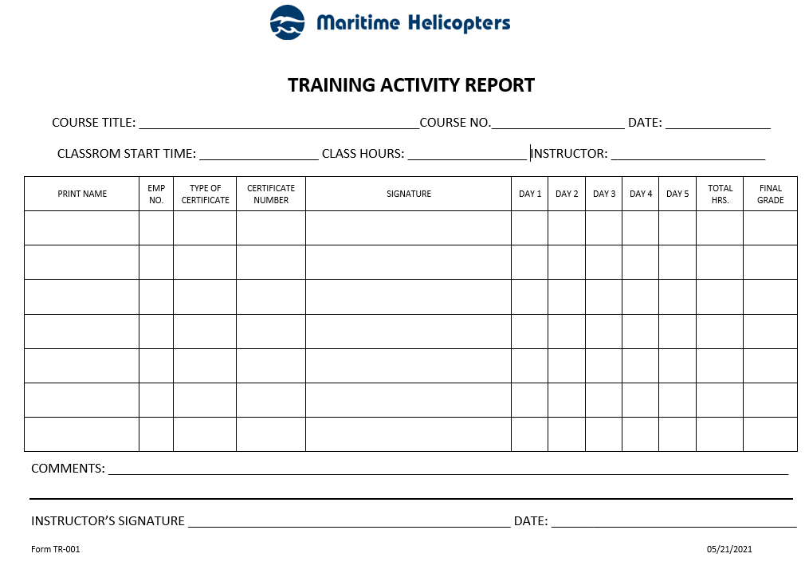

Instructions for completion of Training Activity Report Form TR-001:

1. COURSE TITLE: Title of Course for the activity report.
2. COURSE No: Assigned Course number.
3. DATE: Date of the activity report / date of course.
4. CLASSROOM START TIME: Course beginning time.
5. CLASS HOURS: Hours of course attendance.
6. INSTRUCTOR: Name of Instructor/s.
7. PRINT NAME: Name of course attendee.
8. EMPLOYEE NUMBER: Attendees employee numbers.
9. TYPE OF CERTIFICATE: TBA
10. CERTIFICATE NUMBER: TBA
11. SIGNATURE: Attendee’s signature.
12. DAY 1 through DAY 5: Hours of course attendance.
13. TOTAL HOURS: Total hours for the 5-day period.
14. FINAL GRADE: Grade awarded.
15. COMMENTS: Instructors comments on class.
16. INSTRUCTOR’S SIGNATURE: Signature of instructor.
17. DATE: Date of course completion.

TRAINING VERIFICATION – FORM TR-002
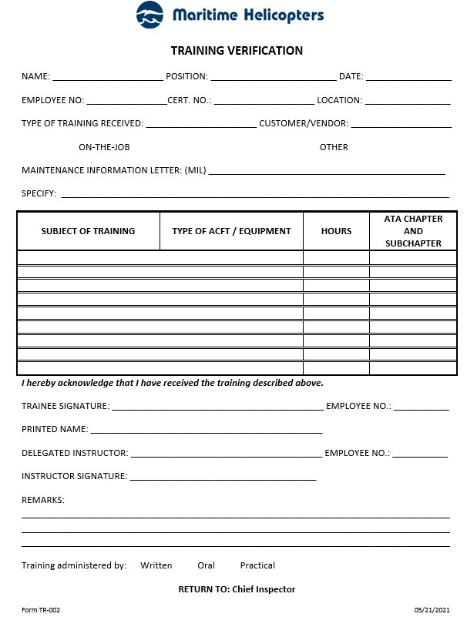

Instructions for completion of Training Verification Form TR-002:

1. NAME: Full name of trainee.
2. POSITION: Trainee’s employment position.
3. DATE: Date of completion of the Training Verification.
4. EMPLOYEE NO.: Employees MHI employment number.
5. CERT. NO.: Employees certificate number, if any.
6. LOCATION: Location where the training took place.
7. TYPE OF TRAINING RECEIVED: Initial / Re-current.
8. CUSTOMER: Customer provided training – check box.
9. ON-THE-JOB: OJT training – check box.
10. OTHER: Check box and specify in either 11 or 12.
11. MAINTENANCE INFORMATION LETTER: (MIL) as issued by MHI.
12. SPECIFY: If 10 is checked, specify type of training received.
13. SUBJECT OF TRAINING/ TYPE OF ACFT/ EQUIPMENT: Course name / aircraft /equipment type for training received.
14. HOURS: Course/Training hours expended.
15. ATA CHAPTER AND SUBCHAPTER: ATA chapter and sub chapter content for the course, if applicable.
16. TRAINEE SIGNATURE: Signature of trainee receiving the course.
17. EMPLOYEE NO.: Employee Number of trainees receiving the course.
18. PRINTED NAME: Printed Name of trainee receiving the course.
19. DELEGATED INSTRUCTOR: Print Instructors Name.
20. EMPLOYEE NO.: Instructors MHI employee number, if applicable.
21. INSTRUCTOR SIGNATURE: Instructor’s signature.
22. REMARKS: Any remarks regarding the course – to be filled out by the instructor.
23. TRAINING ADMINISTERED BY: Check type of instruction technique employed for the course.

EMPLOYEE SKILL SURVEY – FORM TR-003
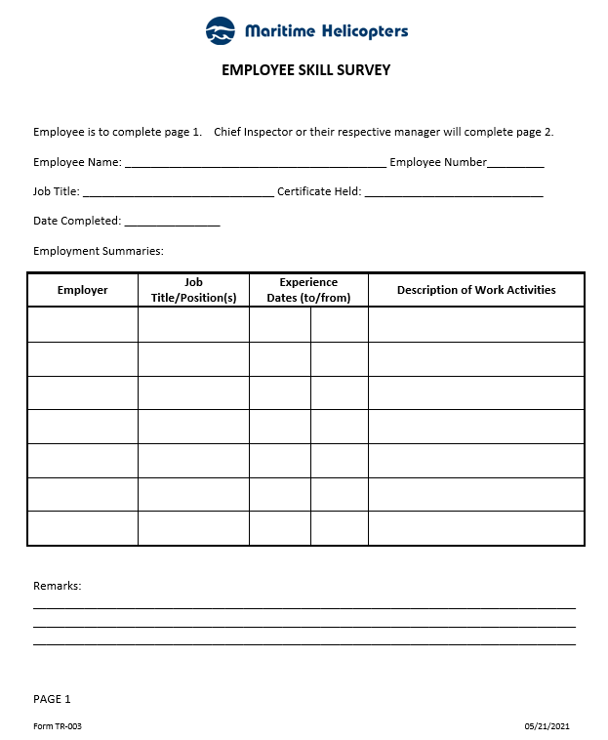

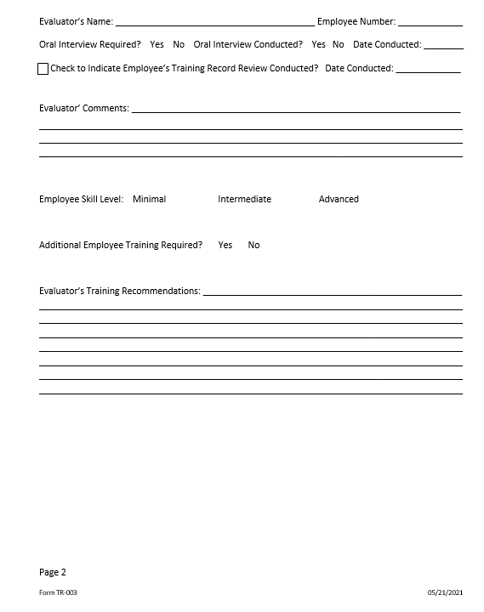

Instructions for completion of Employee Skill Survey Form TR-003:

1. Employee’s name (i.e., John Jet, etc.)
2. MHI employee number
3. Present job title/position (i.e., AMT, Lead, Inspector, etc.)
4. Type and number of 14 CFR Part 65 Certificate held (i.e., A&P 12345678, Repairman 1234567, etc.)
5. Date that employee completed page 1 of form
6. Provide name of employer (i.e., ABC Airlines, XYZ Repair Station, etc.)
7. Provide job title/position(s) held regarding employment (use multiple lines if required)
8. Enter beginning date of employment for positions held
9. Enter ending date of employment for positions held
10. Describe work activities conducted for relevant positions
11. Enter any additional details pertaining to work activities conducted, relevant experience, specialized skills or training that will assist evaluator in determining employee skill-set and overall experience level
12. Name of individual conducting skill survey evaluation
13. MHI employee number of individual conducting skill survey evaluation
14. Indicate if oral interview is required by selecting the appropriate box (i.e., √ or X) Yes or No
15. Indicate if oral interview was conducted by selecting the appropriate box (i.e., √ or X) Yes or No
16. If oral conducted, enter date
17. Check box (i.e., √ or X) to indicate that employee’s training records have been reviewed
18. Enter date that employee’s training record was reviewed
19. Evaluator will enter comments pertaining to evaluation (i.e., employee demonstrates a thorough knowledge of aircraft for both avionics and system maintenance, etc.)
20. Evaluator will check appropriate box (i.e., √ or X) to indicate if employee is of Minimal, Intermediate, or Advanced skill level
21. Evaluator will select appropriate box (i.e., √ or X) Yes or No to indicate if employee requires further training
22. Evaluator will provide details of training recommendation(s) (i.e., Employee will require a BHT 407 General Familiarization class, etc.)

REPAIR STATION NEEDS ASSESSMENT – FORM TR-004
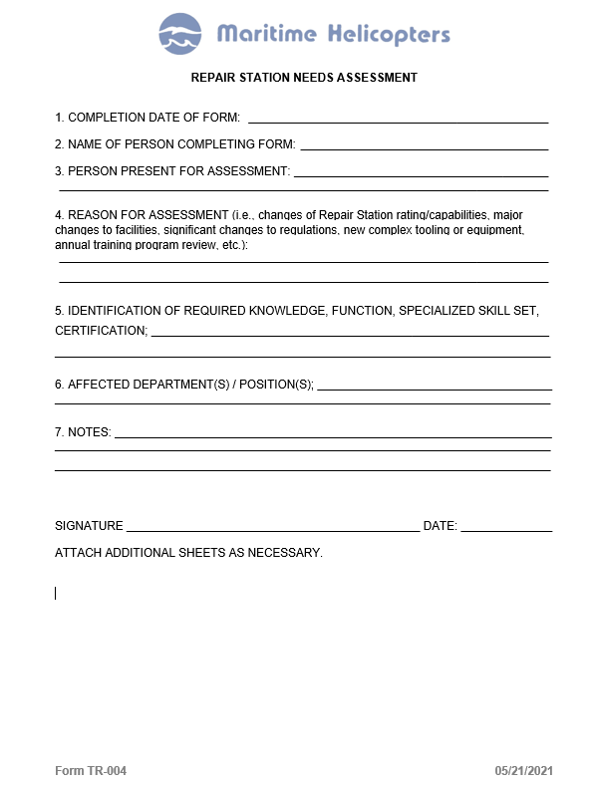

Instructions for completion of Repair Station Needs Assessment Form TR-004:

1. Date form completed.
2. Name of person preparing the form.
3. Individuals present for the assessment.
4. Enter applicable reason for assessment from item 4. If form is being completed for training program annual review, place Annual Review in this field.
5. Insert applicable criteria, (i.e. person performing maintenance, preventative maintenance and /or alteration/inspection functions, skills, experience and training of current employees, assessments of employees being assigned new tasks, return of employee to tasks after extended period, introduction of new regulations, procedures, equipment and record keeping procedures or an upcoming change in nature of basic repair station capability).
6. Departments and positions affected.
7. Add notes as/if required to further document pertinent details discussed during the assessment process including any assigned actions or items requiring further follow-up.
8. Signature of Chief Inspector or his/her designee.
9. Date of signature by Chief Inspector or his/her designee.

COURSE EVALUATION – FORM TR-005
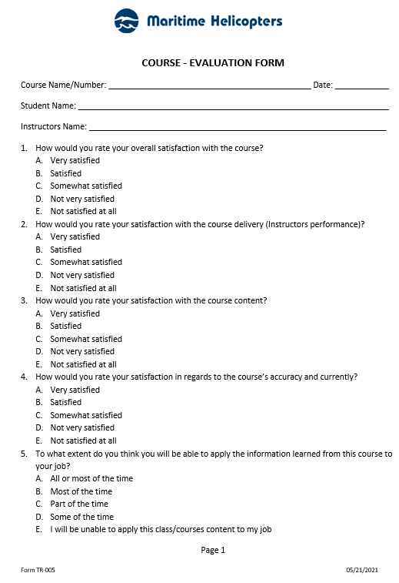

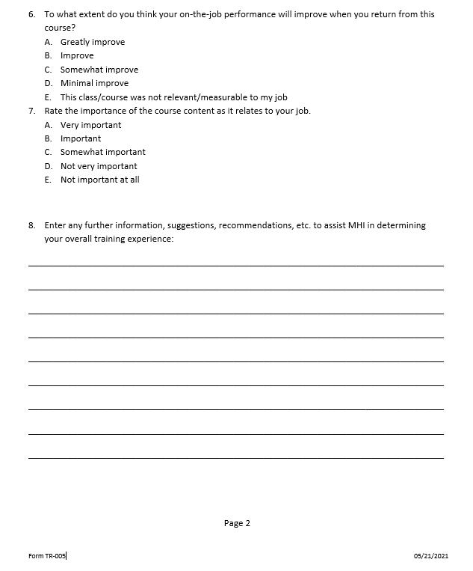

Instructions for completion of Course-Evaluation Form TR-005:

1. Enter Course Name or Number.
2. Enter Date of the course completion.
3. Enter Name of the Student completing the evaluation form.
4. Enter Name of the Instructor giving the course.
5. Answer all questions and circle the relevant answer letter.
6. Enter any notes or other information to assist MHI in determining your overall training experience

