

MARITIME HELICOPTERS

1915 Donald Ave.
Fairbanks, AK 99712

Telephone: (907) 452-1198

FAIRBANKS SATELLITE REPAIR STATION MANUAL
EN2D619D

REVISION 2

08/01/16

PROPRIETARY: ALL RIGHTS RESERVED. NO PORTION OF THIS DOCUMENT MAY BE REPRODUCED OR TRANSMITTED IN ANY FORM OR BY ANY MEANS, ELECTRONIC OR MECHANICAL, INCLUDING BY PHOTOCOPYING, RECORDING OR USE OF ANY INFORMATION STORAGE AND RETRIEVAL SYSTEM WITHOUT EXPRESS WRITTEN PERMISSION OF MARITIME HELICOPTERS. © 2014 MARITIME HELICOPTERS

Published by:
Maritime Helicopters, Inc.
3520 FAA Road
Homer, AK 99603
(907) 235-7771

Copyright © 2014 Maritime Helicopters, Inc.
All Rights Reserved. No part of the contents of this document may be reproduced or transmitted in any form by any means without the written permission of Maritime Helicopters, Inc.
Record of Revisions

MANUAL NO. ______ MANUAL HOLDER ___________________
_

Upon receipt of revisions, insert the revised page(s) in the manual and remove the replaced pages. Enter the insertion date and initials of the person incorporating the revision in the appropriate block on the Record of Revisions. . Return the Revision Notice/Acknowledgment Form MHI 019 to the Part 145 Accountable Manager. This manual will be revised in accordance with Chapter 2 of this manual.

Rev No. | Rev Date | Change Summary | Received Via
Original | 11/01/14
1 | 07/15/15 | Page 3-4 Removed Part 65 Requirement
2 | 08/01/16 | Cert # & Address updated and Rev # added to Cover Page

List of Effective Pages
PAGE | STATUS | DATE |  | PAGE | STATUS | DATE |  | PAGE | STATUS | DATE
i | 2 | 08/01/16 |  | 10-1 | Original | 11/01/14
ii | Original | 11/01/14 |  | 10-2 | Original | 11/01/14
iii | 2 | 08/01/16 |  | 11-1 | Original | 11/01/14
iv | 2 | 08/01/16 |  | 11-2 | Original | 11/01/14
v | Original | 11/01/14 |  | 11-3 | Original | 11/01/14
vi | Original | 11/01/14 |  | 11-4 | Original | 11/01/14
1-1 | Original | 11/01/14 |  | 11-5 | Original | 11/01/14
2-1 | Original | 11/01/14 |  | 12-1 | Original | 11/01/14
2-2 | Original | 11/01/14
3-1 | Original | 11/01/14
3-2 | Original | 11/01/14
3-3 | Original | 11/01/14
3-4 | 1 | 07/15/15
3-5 | Original | 11/01/14
3-6 | Original | 11/01/14
3-7 | Original | 11/01/14
4-1 | Original | 11/01/14
5-1 | Original | 11/01/14
5-2 | Original | 11/01/14
5-3 | Original | 11/01/14
5-4 | Original | 11/01/14
6-1 | Original | 11/01/14
6-2 | Original | 11/01/14
7-1 | Original | 11/01/14
7-2 | Original | 11/01/14
8-1 | Original | 11/01/14
8-2 | Original | 11/01/14
8-3 | Original | 11/01/14
8-4 | Original | 11/01/14
9-1 | Original | 11/01/14
9-2 | Original | 11/01/14
9-3 | Original | 11/01/14

DATE ACCEPTED: ________________________ DATE ACCEPTED: ___________________________

__________________________________________ ________________________________________
FAA PRINCIPAL MAINTENANCE INSPECTOR FAA PRINCIPAL AVIONICS INSPECTOR
JUNEAU FSDO AL05 JUNEAU FSDO AL05

Table of Contents
List of Effective Pages iv
1. Introduction 1-1
2. Manual Revisions 2-1
2.1 Manual Revisions and Control 2-1
2.2 Paper Format 2-1
2.3 Revision Distribution 2-2
3. Organization General 3-1
3.1 General 3-1
3.2 General Statement of Responsibility – Repair Stations Personnel 3-1
3.3 Duties and Responsibilities 3-1
3.4 Delegated Duties 3-5
4. Rosters 4-1
4.1 Roster of Management, Supervisory, and Inspection Personnel 4-1
4.2 Employment Summaries 4-1
5. Description of Operations 5-0
5.1 Operational Work Flow 5-0
5.2 Requisitioning Parts and Materials 5-1
5.3 Disposition of Life Limited and Non-life Limited Aircraft Articles and Materials 5-1
5.4 Record Keeping 5-2
6. Capability List 6-1
6.1 Capability List Revision 6-1
6.2 Self-Evaluation before Revision 6-1
6.3 CHDO Notification and Acceptance 6-2
6.4 Record Keeping 6-2
7. Work Performed at Another Location 7-1
7.1 Fairbanks Satellite Repair Station 7-2
7.2 One Time or Extended Circumstances on a Recurring Basis 7-3
8. Maintenance Performed for Air Carriers 8-1
8.1 Air Carrier Maintenance, Preventive Maintenance, Alterations, and Inspections 8-1
8.2 Communication 8-1
8.3 Coordination and Evaluation of Work 8-2
8.4 RII 8-2
8.5 Duty Time 8-3
8.6 Training Requirements 8-3
8.7 Hazardous Material Training 8-3
8.8 Service Difficulty Report (SDR) 8-4
8.9 Suspected Unapproved Parts (SUPS) 8-4
8.10 Disposition of Suspected Unapproved Parts 8-4
8.11 Reporting of Suspected Unapproved Parts 8-4
9. Contract Maintenance 9-1
9.1 Contract Maintenance to a Certificated and Non-certified Entity 9-1
9.2 Procedure for Development of MHI Master Vendor/Contractor List 9-1
9.3 Procedures to Evaluate Non-Certificated Contractors 9-2
9.4 Procedures to Evaluate Certificated Contractors 9-2
9.5 FAA Approval Procedure 9-2
9.6 List of Approved Vendor 9-3
9.7 Contracted Maintenance Inspection Procedures 9-3
9.8 Provisions for Sub-contracted Air Carrier Products 9-3
10. Equipment and Materials 10-1
10.1 Equipment and Tools 10-1
10.2 Material Control 10-1
10.3 Storage, Preservation and Assignment of Materials and Articles 10-2
10.4 Control of Shelf Life Items 10-2
11. HOUSING AND FACILITIES 11-1
11.1 General 11-1
11.2 Description of Homer Home Base Housing and Facilities 11-1
11.3 Floor Plans 11-2
12. APPENDIX A – FAIRBANKS SATELLITE REPAIR STATION FACILITY 12-1
12.1 General 12-1
12.4 Main Hangar Shop Area Floor Plan 12-3
12.5 West Hangar Floor Plan 12-4
12.6 Avionic Shop Area Floor Plan 12-5
13. APPENDIX B – Repair Stations Forms 13-6

Introduction
This Repair Station Manual (RSM) has been prepared in accordance with the current regulations contained in Title 14 CFR §145, FAA Advisory Circular AC 145-9, and the policies and procedures used at Maritime Helicopters Inc., (MHI). This manual is a prerequisite for operation under the privileges of the Repair Station certificate. The validity of the Repair Station’s certificate is directly dependent upon compliance with the procedures and requirements within this manual, as well as, the associated Quality Control Manual (QCM).

The general maintenance, repair, overhaul, or alteration of products will be performed in accordance with the current Title 14 Code of Federal Regulations (CFR), manufacturer's data, drawings, specifications and bulletins, or other technical data accepted or approved by the administrator for the particular ratings as noted in the Repair Station’s operational specifications.

MHI Homer Home Base or Satellite Repair Station will not maintain or alter any article for which it is not rated, and will not maintain or alter any article for which it is rated if it requires technical data, equipment, materials, facilities or trained personnel that are not available.

A current copy of this RSM, including the associated QCM and Repair Station Forms Manual (RSFM), shall be accessible to all Home Base and Satellite Repair Station personnel required by subpart D. A current copy of the required RSM and any revisions made will also be provided by electronic copy to the FAA Certificating Holding District Office (CHDO).

The Repair Station must allow the FAA to inspect that Repair Station at any time to determine compliance with title 14 CFR §145.223

Manual Revisions
The Accountable Manager oversees the creation and revision of MHI controlled documents. Department Managers and Supervisors may submit suggestions and corrections for incorporation into this manual by contacting the Chief Inspector. Changes made to this manual will be summarized in the change summary table and indicated throughout the manual by change bars. A vertical bar (change bar) in the right margin indicates a change, addition, or deletion in the adjacent text for the current revision of that page only. The change bar is dropped at the next revision of that page. The effected paged will also be annotated by updating the revision level and date in the top right hand corner. The list of effected pages will also be updated.

Following approval by the Accountable Manager, the Chief Inspector shall submit the proposed revision in hard copy, or electronic PDF format, to the Federal Aviation Administration (FAA) for review and acceptance. Should a proposed revision be found unacceptable by the FAA, the Accountable Manager will immediately withdraw the proposed revision and decide whether to further revise and resubmit to the FAA.

Manual Revisions and Control

The Chief Inspector is responsible for the content of this manual and any revisions. This manual requires FAA acceptance prior to release. Revisions to this manual must be routed for MHI internal and FAA acceptance prior to distribution. This manual cannot be published or distributed to end users prior to formal submission to and acceptance by the FAA.

The Part 145 Accountable Manager shall be responsible to maintain MHI Master Manual Distribution List Form MHI 020, listing individuals that have been assigned manuals in paper format. The listing shall indicate the name of the individual, name of the manual, manual number, revision number, and the date the completed Revision Notice/Acknowledgment, Form MHI 019 was received.

Paper Format

Hard copy manuals shall be issued by the Part 145 Accountable Manager under a manual control number and revision notification controlled by the Revision Notice/Acknowledgment, Form MHI 019 indicating receipt of revision and incorporation into the manual. Hard copies of the manual shall be issued to Director of Maintenance, Part 145 Accountable Manager, Chief Inspector, the CHDO and Part 145 personnel working away from base.

A copy shall be posted on the company website and accessible Part 145 personnel required by Part 145 Subpart D. The web manual shall be maintained by the Accountable Manager. All manual holders shall be responsible to insert revisions, update the Record of Revisions page by entering the Revision Number, Date, Date Inserted, Revisions Inserted By, and return the completed Revision Notice/Acknowledgment, Form MHI 019 to Part 145 Accountable Manager to indicate the manual has been revised.

Revision Distribution

The manual shall be revised as necessary and a hardcopy of each revision shall be forwarded to the individuals that have been assigned manuals in paper format, per MHI Master Manual Distribution List Form MHI 020. A copy of each revision shall be forwarded to the CHDO, either by hard copy through the postal service or electronic format through e-mail. FAA inspectors will either accept or reject the manual revision. The FAA inspector will, by letter, inform the repair Stations of acceptance or rejection. The letter will address the manual title, manual date, and revision number. If the manual is rejected, the FAA inspector will provide a detailed explanation of the deficiencies and advise the repair Stations.

Organization General

General

This section provides a description of the MHI organization, complete with duties and responsibilities as well as reporting structure. An organization chart is also provided in this section. In addition to each management position with assigned authority to act on behalf of the repair Stations, each subordinate and senior management positions are identified. Personnel shall be able to identify their reporting structure and understand assigned duties and responsibilities by referring to this section.

Organization Chart

QA Department
Director of Maintenance
FAA Accountable Manager
Homer and Fairbanks

Managerial Control Organization Chart

Inventory Administrators
Lead Mechanic

Chief Inspector
Training Manager

Maintenance Department
Inspectors/Receiving Inspectors
Mechanics

General Statement of Responsibility – Repair Stations Personnel

All personnel assigned to any MHI Repair Stations are required to be familiar with the requirements of this manual, applicable FAA regulations, and airworthiness directives. All personnel assigned to MHI Homer Home Base and Fairbanks Satellite Repair Station shall adhere to the policies and procedures of this manual, and to applicable FAA regulations and associated guidance.

All management and lead personnel may delegate their assigned duties to any qualified individual as necessary; however, such delegation does not relieve them of their overall responsibility.

Duties and Responsibilities

Part 145 FAA Accountable Manager

The Part 145 Accountable Manager is responsible for the overall operation of the Homer Repair Station and Fairbanks Satellite Repair Station in accordance with the applicable CFRs. The Part 145 Accountable Manager shall act as the FAA Accountable Manager with responsibilities as defined in Title 14 CFR §145.3(a) for each of the MHI Repair Stations. These duties include maintaining an adequate and knowledgeable staff to plan, perform, supervise, and inspect the work being performed on civil aviation articles within the repair station. The Part 145 Accountable Manager shall ensure that CRS management adheres to and enforces the policies and procedures of this manual.

The Part 145 Accountable Manager is responsible for:

Directing, planning, and implementing the details for inspection standards, methods, and procedures used by each of the repair Stations to comply with applicable FARs (CFR's), and manufacturer's specifications and recommendations;

Ensuring that all inspections are correctly performed on articles that are maintained by the Repair Stations and that the inspection records, reports, and forms used by assigned mechanics are properly executed prior to presenting the article to the inspection department;

Assuring that all alterations and maintenance procedures are performed according to FAA approved or acceptable data, as well as, manufacturer’s recommendations and pertinent FAR’s;

Providing adequate equipment, materials, technical data, and competent personnel pertinent to the operations of repair Stations in order to comply with applicable FAA (CFR) and manufacturer's recommendations, and to establish standards to ascertain that adequate safety precautions are observed;

Ensuring the Repair Station training program meets the requirements of Title 14 CFR §145.163.

Providing training as necessary for personnel to become familiar with aircraft, aviation products, product improvements, and proper work procedures and practices that are to be followed;

Ensuring all applicable technical data used is current and posted properly;

Ensuring that all equipment and tools used for maintenance are maintained in serviceable working condition;

Maintaining and controlling the rental/lease equipment;

Ensuring the proper tagging and identification of all parts and components as applicable;

Ensuring that all precision tools and test equipment used by both the repair Stations are calibrated;

To ensure that no defective, unserviceable, unairworthy parts or materials are installed in any article maintained;

Ensuring that rejected and unserviceable parts are handled in such a way as to prevent their reuse;

Oversight of maintenance that is contracted to approved vendors.

Reporting of Suspected Unapproved Parts to the Chief Inspector.

Maintenance Training Manager

The Maintenance Training Manager reports to the Part 145 Accountable Manager and is responsible for the operation and training performed at each of the MHI Repair Stations and has overall authority for the training program.

In addition the Maintenance Training Manager is responsible for:
- Ensuring that the Repair Station Training Manual (RSTM) is used to conduct the Repair Station training program;
- Ensuring compliance with all of the components of the training program;
- Ensuring that training methods and resources selected will provide the necessary information and are appropriate for the desired training outcome;
- Monitoring training resources to ensure the Repair Stations is aware of their alternatives;
- Conducting an audit of outside vendor training courses as applicable;
- Ensuring that training resources are developed that will satisfy the Repair Stations and individual employees training needs;
- Evaluating the overall each Repair Stations training needs and revise the training program as necessary;

Chief Inspector

The Chief Inspector reports to the Part 145 Accountable Manager for the operation of the Quality Assurance Department.

The Chief Inspector is responsible for:
- Assisting, training, and supervising personnel assigned to the Quality Assurance Department;
- Ensuring persons performing inspections are familiar with the applicable regulations in Title 14 CFR §145 and with the methods, techniques, practices, aids, equipment and tools used to perform the maintenance, preventive maintenance, or alterations. They must be proficient in using the various types of inspection equipment and visual aids appropriate for the article being inspected;
- Ensuring required precision tools and test equipment used by the Repair Station for the purposes of conformity and return to service are calibrated;
- Ensuring required precision tools and test equipment used by the Repair Stations for the purposes of conformity and return to service are calibrated;
- Ensuring that all defective, rejected, unserviceable, or unairworthy parts are controlled and properly segregated to prevent their installation or reuse in any component or article released by the repair Stations;
- Submitting service difficulty reports (SDR) in accordance with Title14 CFR §145.221;
- Ensuring the accomplishment of final acceptance of all incoming material and articles to determine serviceability and to assure the proper execution of the suspected unapproved parts program;
- Ensure preliminary, hidden damage, in-progress, and final inspection of all articles processed by the Repair Stations, as well as record results, as outlined in this manual, are properly performed;
- Monitoring the proper tagging and identification of all parts and components as applicable;
- Continuity of inspection responsibility and assuring completion of required inspection when assignment changes occur;
- Maintaining files of completed work orders;
- Maintaining a roster of management, lead, and inspection personnel for each MHI repair Station.

Inspector

The Inspector reports to the Chief Inspector and is responsible for the efficient and economical determination of airworthiness of aircraft maintenance and other work assigned for inspection.

The Inspector is responsible for:

- Ascertaining that work for which he/she is responsible has been accomplished in a high standard of workmanship and in accordance with MHI, FAA, and manufacturer’s standards;
- Ensure that all necessary parts tags for which he/she is responsible are correctly executed for units or parts changed;
- Perform inspections of articles, products, facilities, vendors, equipment as directed by the Chief Inspector;
- Conduct incoming and stockroom inspections for proper tagging, bagging, storage, shelf life and good housekeeping;
- Performing technical research as required to determine status/compliance of aircraft or components/systems;
- Reading, writing, speaking and understanding the English language;
- Ensuring completion of logbook entries as/when required;
- Ensuring compliance with all applicable CFRs during the course of assignments;
- Performing inspections only on products for which they have been properly trained and qualified;
- Conducting OJT (On-the-Job Training);
- Reviewing, auditing, copying, and controlling MHI aircraft records as directed by the Chief Inspector;

NOTE: The duties and responsibilities of the Inspector may be delegated to any qualified individual; however, such delegation must be approved by the Chief Inspector and does not relieve the Chief Inspector of the overall responsibility.

Incoming and Receiving Inspector

The Incoming and Receiving (IR) Inspector reports to the Chief Inspector for performing receiving inspection requirements for;

- Inspectors assigned to receiving shall be properly trained on procedures to inspect incoming materials. This assignment will be annotated on the repair Stations roster.
- Advisory Circular AC 20-62E (as revised) provides guidance on Eligibility, Quality, & Identification of Aeronautical Replacement Parts. New and continued service parts for serviceability, including but not limited to, verifying certification from manufacture or overhaul facility and inspecting for shipping damage.
- Conduct incoming and stockroom inspections for proper tagging, bagging, storage, shelf life and good housekeeping;

Leads

The leads report to the Part 145 Accountable Manager for the operation of their respective area.

In addition, the Leads are responsible for/to:

- Assist and supervise all personnel assigned to their respective area;
- Ascertain that all maintenance and inspections are correctly performed on articles that are maintained by their respective shop and that the inspection records, reports, and forms used by assigned technicians are properly executed prior to presenting the article to the inspection department;
- Ensuring that there is adequate training, equipment, and materials for all projects;
- Ensuring all applicable technical data used within the repair Stations is current and posted properly;
- Ensuring that all equipment and tools used for maintenance are maintained in serviceable working condition;
- Maintaining and controlling the rental/lease equipment;
- Ensuring the proper tagging and identification of all parts and components as applicable;
- Ensuring that all applicable precision tools and test equipment used by the repair Stations are calibrated;
- Ensure that no defective, unserviceable, unairworthy parts or materials are installed in any article maintained under their assigned repair Stations authority;
- Ensure that rejected and unserviceable parts are handled in such a way as to prevent their reuse;
- Reporting of Suspected Unapproved Parts to the Chief Inspector

Mechanics

The Mechanic is responsible to the Lead for the daily performance of his/her duties.

The Mechanic is responsible for:

- Reading, writing, speaking, and understanding the English language;
- Reading and interpreting aircraft maintenance manuals, structural repair manuals,
- safety manuals, Illustrated Parts Catalogs, FAA regulations, Airworthiness Directives, and blueprints involving various repairs, part locations, and replacement;
- Troubleshooting aircraft systems and repairing in accordance with accepted/approved data;
- Removing and replacing any and all parts using accepted/approved data;
- Demonstrating knowledge of aircraft systems;
- Following safety rules and procedures;
- Following FAA and company policies and procedures;
- Keeping work area clean and neat at all times;
- Other duties as assigned by the Part 145 Accountable Manager.

Inventory Administrators

The Inventory Administrators are responsible to the Accountable Manager for the daily performance of his/her duties.

The Inventory Administrators is responsible for:

- Receives, unpacks and records incoming shipments and prepares items for receiving inspection;
- Tags and stocks items after inspection (if required);
- Ensures parts issued from stock are recorded;
- Maintains cleanliness and protection of items in stock.
- Assures that older stock is used first in-first out and that shelf time limits are observed;
- Inventories and records stock levels as requested;
- Assists with maintaining Repair Stations records and paperwork as assigned by Accountable Manager.

Delegated Duties

In the absence of any responsible supervisory/management employee, the duties and responsibilities shall be delegated to a qualified replacement in order to ensure required duties and responsibilities continue to be accomplished. Delegated duties may only be assigned to a qualified individual. It shall be the responsibility of the individual authorizing the delegation of duties and responsibilities to determine the capabilities of each candidate for delegation. The individual authorizing the delegation shall remain ultimately responsible for the proper accomplishment of all delegated duties and responsibilities.

Rosters

Roster of Management, Supervisory, and Inspection Personnel
The Chief Inspector shall maintain a roster of management, supervisory, and inspection personnel for both the Homer Home Base and Fairbanks Satellite Repair Station. These rosters shall be made available for inspection by the FAA upon request. A roster of the names for each of the Repair Stations personnel who are responsible for its management and the names of its supervisors who oversee maintenance functions will be maintained.

A roster of the names of each stations inspection personnel, including those who are authorized to sign a maintenance release, as well as, a records entry for approving a maintained or altered article for return to service will be maintained. Required Inspection Item (RII) inspector approval, identified by an Air Carrier, shall also be included on this roster.

Certain conditions may require changes to these rosters, including:

- New employment under the repair Stations.
- Reassignment between Homer or Fairbanks Repair Stations
- The termination of employment of any person on the roster;
- The assignment of duties to any person who is not listed on the required roster, but is required to be listed;
- Any appreciable change in the duties and scope of assignment of any person on the roster.
- Managers and Supervisors are required to inform the Chief Inspector of personnel changes within the repair Stations by completion of employment summary, Form MHI 016. These changes shall be completed and the roster amended within 5 business day.

Employment Summaries

The applicable management will approve any person who is to be listed in a management or lead position that is on the roster of management, or supervisory and inspection personnel roster. The Chief Inspector will approve any person who is to be designated as an inspector or have return to service privileges. For these persons, an employment summary, Form MHI 016 must be submitted. This summary shall be included in the files maintained by the Chief Inspector. This employment summary shall contain the required information as listed in Title 14 CFR § 145.161(a).

Description of Operations
This section includes a general description of the operations and workflow at the Repair Stations. The use of work order forms are outlined in the Repair Stations Forms Manual, while the inspection processes are outlined in the associated Quality Control Manual.

The Repair Station will only operate in accordance with the ratings and operation specifications issued.

Operational Work Flow

Work Order Initial Process

This is the process for creating an original maintenance request for aircraft and articles that are under a MHI Repair Station’s work order or for making in progress changes requested by a customer to the Statement of Work (SOW), or original request for maintenance.

The request for a change to the sow or the original maintenance request may come from the customer, customer representative, or from the Part 145 Accountable Manager. This communication may be accomplished via e-mail, FAX, written customer transcript.

The customer must authorize any change to the sow, or original maintenance request.

The change as authorized will be communicated by the Part 145 Accountable Manager to maintenance and Quality Assurance department. This communication may be accomplished in a variety of ways:

- Electronic (e mail)
- FAX
- Written transcript

A copy of the document authorizing the change will be included in the work order package. The maintenance requirements associated with the change will be added as line items to the Part 145 Work Sheet, form MHI 005.

Aircraft
An aircraft being considered for induction into any MHI Repair Station shall have a determination made by the appropriate manager/lead whether the MHI Repair Station has the appropriate ratings or capabilities to induct the aircraft into that repair Station.

Upon receipt of a Statement of Work (SOW) or an approved customer order the assigned quality assurance inspector will open a work order, complete the work order cover sheet, form MHI 002, and an aircraft preliminary inspection will be performed. Any changes to sow or original maintenance request will be communicated by the Part 145 Accountable Manager from the customer.

Article
An article (aircraft, airframe, aircraft engine, propeller, appliance or component part) being considered for induction into a MHI operated Repair Station must be received with proper serviceability documentation.

A copy of the serviceability documentation will be forwarded to the Quality Assurance Department. QA personnel will then open a work order, complete the work order cover sheet, form MHI 002, conduct a preliminary inspection, and verify the part number and serial number, as applicable.

Work Order
Each MHI Repair Station’s maintenance personnel perform maintenance, preventive maintenance, alteration, and repairs as annotated in the work order. All work performed is recorded in the Part 145 Work Sheet, form MHI 005.

All required functional checks or inspections associated with completed maintenance will also be recorded in the Part 145 Work Sheet, form MHI 005, or check list, as applicable.

Upon completion, the work order is reviewed by the appropriate supervisory personnel. After review, the work order is submitted to the Quality Assurance Department. After quality assurance reviews the work order for completeness of all airworthiness documentation, the assigned inspector will sign the maintenance release on the work order cover sheet, form MHI 002.

The aircraft/article is then returned to service and the work order is closed and filed by the Quality Assurance Department.

Requisitioning Parts and Materials

This section includes a general description for requisitioning parts and materials required for a job under a MHI Repair Station work order. Mechanics requesting a part(s) will submit a parts request to the Part 145 Accountable Manager. Parts entering MHI operated repair stations will undergo an incoming and receiving inspection. Upon receiving the part, the mechanic will inspect the part for general serviceability. Materials that have a shelf life expiration date are inspected by receiving personnel for verification of expiration dates.

Disposition of Life Limited and Non-life Limited Aircraft Articles and Materials

Service life limited articles which have reached their service life limit, and non-life limited aircraft articles which cannot be repaired or are otherwise deemed unairworthy, shall be disposed of in the following manner.

- Unsalvageable parts awaiting mutilation shall be segregated from serviceable or repairable components and identified with a rejected parts tag, form MHI 007. The tag will include a brief statement indicating that the article was mutilated and how it was disposed of.
- The historical service record (“Hard Card”), if one exists for the expired component, can be updated upon customer request to show the cumulative time on the component. An entry will be made stating that the component has been removed from service due to reaching its service life limit, unairworthy, etc.
- The data tag on the article, if there is one, shall be removed. If there is an etched part number and/or serial number on the article, it shall be crossed out by vibroetching, stamping, or by other suitable means.
- The article itself shall be physically mutilated to make it either impossible to reinstall onto an aircraft (or into an assembly) or to make it incapable of being re-worked to appear to be airworthy.
- Acceptable means of permanently mutilating unsalvageable articles include grinding, burning, removal of a major lug or other integral feature, permanent distortion of the article, cutting a hole into the article with cutting torch or saw, melting, or sawing into pieces. Other means of mutilating articles may also be used.

Disposition of an unsalvageable aircraft article being released for training purposes, or as an aircraft work aid, tooling jig, or for research and development purposes, must be handled in the following way;

- The data tag on the article, if there is one, shall be removed. If there is an etched part number and/or serial number on the article, it shall be crossed out by vibroetching, stamping, or by other suitable means.
- If possible, the article shall be mutilated. However, if mutilation of such an article will render it useless for the proposed educational, work aid, tooling, or research and development project then the article shall be clearly and permanently marked “UNSERVICEABLE”. Ink stamping alone shall not be considered sufficient for this purpose.
- If feasible, the article should be painted in a conspicuous color so that it cannot be mistaken visually for a serviceable article.
- If the article is to be transferred from Maritime Helicopters to another person or organization, there shall be a written contract with that person or organization specifying that the article being transferred is known to be non-airworthy and is incapable of being returned to an airworthy status. In addition, the contract must specify that the recipient of the article is responsible for the appropriate final disposition of that article.

Any historical record that exists for the article shall remain in the possession of Maritime Helicopters and not be transferred to the new owner of the article.

Record Keeping

These procedures apply to all maintenance and quality assurance personnel assigned to each of the MHI Repair Stations. It is the responsibility of the Part 145 Accountable Manager to ensure the required aircraft and article records are accurate and complete before the data is routed to the Quality Assurance Department. It is the responsibility of the Chief Inspector to ensure the required records are accurate and complete before the work order is stored
A record shall be kept of applicable work performed by each of the repair stations, and these records shall be maintained by the Chief Inspector. These files are maintained for a minimum of 2 years after the return to service of the article. For articles not being returned to service, files shall be maintained for a minimum of 2 years after the last work performed. Records of Repair Station work orders shall be available upon request to authorized representatives of the Federal Aviation Administration (FAA) and the National Transportation Safety Board (NTSB).

These records or work order packages consist of each of the Repair Stations work order cover sheet, form MHI 002 and all other supplementary forms, checklists, documents, and article serviceability or traceability paperwork utilized in the accomplishment of the maintenance or alteration of an article.

The completed work order packages will be stored in a secure environment at each of the MHI operated Repair Stations that performed the work.

A maintenance release or return to service entry, in accordance with Title 14 CFR §43.9 and/or §43.11, shall be provided to the owner/operator of the aircraft/article upon delivery.

This maintenance release or return to service is provided in the format of an entry into the aircraft log or the articles maintenance record (as provided by the owner/operator). Completion of the Serviceable Parts Tag, form MHI 006 or FAA Form 8130-3, may also constitute a maintenance release.

Capability List
The Chief Inspector and the Part 145 Accountable Manager are jointly responsible for the accuracy and currency of the Capability List. Current copies of the Capability List will be on file in the Chief Inspector Office. Fairbanks Satellite Repair Station may only perform ratings currently approved for the MHI home station.

With regards to Limited Ratings, each of the repair stations may perform maintenance, preventive maintenance, or alterations on an article listed on a current Capability List that is acceptable to the FAA, or on the Homer home base repair station operational specifications. An article may only be listed on the Capability List if it is within the scope of the repair station’s certificate, and after the repair station has performed a self-evaluation in accordance with CFR §145.209(d)(2) and this section.

The Capability List will be maintained in a current status and revised as required to agree with operating changes, policies, and procedures. To ensure accuracy, the Capability List will be reviewed by the Part 145 Accountable Manager, in conjunction with the Chief Inspector, on a continual basis, but at a minimum an annual review shall be performed. The Part 145 Accountable Manager shall perform and record the results of the annual review on the Capabilities Self-Evaluation Checklist, Form MHI 017. This form will then be submitted to the Chief Inspector for review. If no changes are required during the annual review the Capability List will stay at the current revision status.

Capability List Revision

The Capability List will be revised at such time as each repair Stations technical capabilities, equipment, data, or work requirements change in such a way that an article or capability needs to be added, modified or deleted. The Fairbanks Satellite Repair Station may only perform capabilities approved for the Homer home base. The portion of the text affected by the latest revision will be indicated by a vertical line on the right side.

The Capability List will have the affected articles identified by make, model, or other nomenclature designated by the articles manufacturer. The list shall also indicate the certified repair Stations number, revision level, page number(s), and the approving signatures for which the rating is approved for.

Self-Evaluation before Revision

Prior to making any revisions to the Capability List, the following shall be complied with:
- The Part 145 Accountable Manager shall perform a capabilities self-evaluation at both the Homer main base and Fairbanks Satellite Repair Station to verify that adequate housing, facilities, tools, equipment, materials, technical data, processes, and trained personnel are available for the capability requested.

- Results of the self-evaluation shall be documented on the Capabilities Self-Evaluation Checklist, Form MHI 017 which will then be submitted to the Chief Inspector for review.

- Upon satisfactory review of the Capabilities Self-Evaluation Checklist, the Chief Inspector will have the necessary revisions of the Capability List produced in a final format. The portion of the text affected by the latest revision will be indicated by a vertical line on the right side of the page.

- The Chief Inspector shall file the newly revised Capability and notify the applicable management via e-mail.

CHDO Notification and Acceptance

The Chief Inspector shall provide any revised Capability List, and the associated Capabilities Self-Evaluation Checklist, to the FAA Certificate Holding District Office (CHDO) within five (5) business days after the revision. This may be provided by either hard copy or electronic communication.

Record Keeping

The Chief Inspector shall maintain records of all revised Capability Lists and Self-Evaluation Checklists for each repair station for a minimum of two years.

Work Performed at Another Location

This repair station can provide maintenance for aircraft which are based at locations away from the repair station to include performing maintenance on a recurring basis at a set location.

Only maintenance for which the MHI Homer repair station is rated may be performed. Maintenance can, under the direction of the Accountable Manager, be performed by other certified repair stations.

The Accountable Manager is responsible for:

- Assigning properly qualified personnel necessary to perform the work.
- Ensuring proper tools and equipment are available on site and in current calibration.
- Establishing the availability of safe work areas protected from the elements.
- Arranging an accessible effective communication system for work away from this repair station.
- Ensures the RSM and QSM are available to all personnel.

The Chief Inspector is responsible for:

- Assembling technical information and required forms for the maintenance planned at other locations.
- All parts go thru a incoming/receiving inspection in accordance with MHI QCM and are properly segregated.
- Ensuring the documentation of work and the inspection procedures are performed at the remote location as they are at this repair station. Work shall be performed in the same manner and in accordance with FAR 145.57 through 145.61 and MHI RSM and QCM manuals.

The Inventory Administrators is responsible for:

- Collecting necessary support materials.
- Providing transportation for the materials between the repair station and remote locations.

If the work planned is the result of either one-time or extended special circumstance, the Chief Inspector is responsible for contacting the CHDO for approval. Initial contact may be telephonic, but a written request will be transmitted via the fastest possible means, (fax, e-mail, or hand carried) to include a roster of personnel assigned. A copy of the written request and the approval will become part of the work order packet and shall be kept on file with the work order. Should the request be denied, a copy of the letter and the denial will be kept on file by the Chief Inspector.

Occasions may arise which require work that goes beyond the extent of work initially planned. The Accountable Manager is responsible to provide the necessary personnel. The Chief inspector shall determine the limit of increased inspection criteria and obtain FAA approval if necessary. The Inventory Administrators are responsible for assembling and providing transportation of the required materials.

Fairbanks Satellite Repair Station

Homer home base specifies the types of work and how it shall be performed by its satellite repair station in the RSM/QCM manuals. Fairbanks shall not perform any ratings not approved at the Homer home base and must have the proper facilities, materials, equipment and personnel for each maintenance activity. Fairbanks shall at all times be in compliance with the Homer FAA approved Part 145 Repair Station and Quality Control Manuals. Any operational/procedural and informational differences at the satellite station shall be identified and address in the Fairbanks Repair Station Manual (RSM). Minor differences such as the description of housing are annotated in the Repair Station Manual Appendix.

Satellite locations must meet basic facility requirements for any ratings to be performed. This includes proper lighting, ventilation, temperature control, plus size sufficient for safe accomplishment of maintenance performed. Work may only be performed at Satellite Repair Stations of which the Homer home base has been approved by the FAA approved Capabilities List. At no time is the Satellite Repair Station authorized to perform maintenance not previously approved for the Homer home base.

The home base shall ensure sufficient qualified personnel, equipment and materials are stationed at the Satellite Repair Station or temporarily assigned/shipped there for proposed maintenance operations. Additionally, Satellite Repair Station maintenance personnel must be trained under Maritimes Repair Station Training Program prior to performing any maintenance functions.

Work orders will be utilized for all maintenance performed. Completed work orders will be reviewed by the inspector(s) and then forwarded to the home base to be filed for a minimum of 2 years and available for review by the Administrator. Any repair or alteration that requires a FAA 337 form must provide the home base with all documents associated with the repair or alteration. Home base will review all documents and grant approval.

When performing maintenance at a Satellite Repair Station, the Homer home base shall provide or ensure the following are onsite and qualified;

- Inspectors, supervisors and return-to-service personnel.
- Designate inspection personnel for airworthiness determination.
- Current technical data appropriate for the work to be performed.
- Any manufacturers special tooling or test equipment.
- Proper forms to include work orders, parts tags, etc.
- All tools and instruments are in current calibration.
- Current copy of Approved Repair Station & Quality Control Manual.

The Chief Inspector shall maintain appropriate rosters of temporary management, supervisory, and inspection personnel. These rosters shall be provided to the FAA upon each circumstance request.

One Time or Extended Circumstances on a Recurring Basis

Maritimes home base may be required to provide one time maintenance and/or extended maintenance at a remote location on a recurring basis. During such activities, the home base will retain overall authority and coordination for all maintenance. All work shall be performed in accordance with Maritimes approved Repair Station and Quality Control manuals.

When remote work is required, Maritime Helicopters shall contact the local CHDO and request approval to temporarily perform maintenance on a recurring basis under CFR §145.203 (b). Each request will include a personnel roster of those assigned. Remote locations may only perform ratings currently approved for the MHI home station.

Remote locations must meet basic facility requirements for any ratings to be performed. This includes proper lighting, ventilation, temperature control, plus size sufficient for safe accomplishment of maintenance performed.

The Homer home base shall ensure sufficient qualified personnel are stationed at the location or temporarily assigned there for proposed maintenance operations. Additionally, maintenance personnel must be trained under Maritimes Repair Station Training Program prior to performing any maintenance functions.

Work orders will be utilized for all maintenance performed. Completed work orders will be reviewed by the inspector(s) and then forwarded to the home base to be filed for a minimum of 2 years and available for review by the Administrator. Any repair or alteration that requires a FAA 337 form must provide the home base with all documents associated with the repair or alteration. Home base will review all documents and grant approval.

When required to support maintenance at a remote location on a recurring basis, the home base shall provide or ensure the following;

- Inspectors, supervisors and return-to-service personnel.
- Designate inspection personnel for airworthiness determination.
- Current technical data appropriate for the work to be performed.
- Any manufacturers special tooling or test equipment.
- Proper forms to include work orders, parts tags, etc.
- All tools and instruments are in current calibration.
- Current copy of Approved Repair Station & Quality Control Manual.

The Chief Inspector shall maintain appropriate rosters of temporary management, supervisory, and inspection personnel. These rosters shall be provided to the FAA upon each circumstance request.

Maintenance Performed for Air Carriers
These procedures apply to maintenance, preventive maintenance, and alterations performed for certificate holders under Title 14 CFR §121, §125, and §135. MHI will not at this time perform maintenance, preventive maintenance, or alterations for a foreign air carrier or foreign person operating a U.S.-registered aircraft under 14 CFR Part 129. It is the responsibility of the Title 14 CFR §121, §125 or §135 certificate holder to ensure the Repair Stations has the current data required to perform maintenance, preventive maintenance, and alterations in accordance with their respective FAA approved program and/or applicable sections of their program and Maintenance Manual.

Air Carrier Maintenance, Preventive Maintenance, Alterations, and Inspections

When MHI performs maintenance, preventive maintenance, or alterations for an air carrier that has a continuous airworthiness maintenance program under Title 14 CFR §§121 and 135 or an approved aircraft inspection program under Title 14 CFR §135, the work must be performed in accordance with the air carrier’s program and applicable sections of their Maintenance Manual.

When MHI performs an inspection for a certificate holder conducting operations under Title 14 CFR §125, the inspection must be performed in accordance with the operator’s FAA approved inspection program. Any deviation from that program must be authorized by the air carrier. This includes technical data used for repairs or alterations.

When MHI performs maintenance, preventive maintenance, or alterations for an operator that has a continuous airworthiness maintenance program (CAMP) under 14 CFR Part 91, Subpart K, MHI will follow the operator's program and applicable sections of its maintenance manual.

Communication

The Part 145 Accountable Manager is the initial MHI contact for contracted work to be performed. The Part 145 Accountable Manager shall initiate the Contract Maintenance Checklist (Form MHI 022).

The Part 145 Accountable Manager shall conduct a meeting with the Chief Inspector to review the work scope for the contracted work to be performed, determine necessary support requirements, and select the necessary support personnel. The Part 145 Accountable Manager will advise all affected personnel once a customer contract has been completed so the Contract Maintenance Checklist (MHI Form 022) can be completed by the assigned personnel. MHI can make the appropriate preparation and necessary arrangements.

Coordination between the Repair Station and the operator is essential to maintaining compliance with the operator’s program. Upon signing the contract, immediate communication between the repair Stations and the operator must take place so that MHI can make the appropriate preparation and necessary arrangements.

The Chief Inspector shall contact the operator’s quality department and request a copy of the operator’s maintenance manual and details of training requirements as outlined on Contract

Maintenance Checklist (MHI Form 022). Operator points of contact for training shall be established and provided to the MHI Chief Inspector.

Coordination and Evaluation of Work

The Chief Inspector shall evaluate the operator’s maintenance manual and ensure no work is started until all operator requirements have been met.

It is the Chief Inspector’s responsibility to ensure that the Repair Station follows the procedures given by the air carrier, including special maintenance or alteration instructions per engineering orders, build lists, and other methods, techniques, and practices in the Operator’s Manual per Title 14 CFR §43.13 (c).

Part 145 Accountable Manager is responsible for ensuring the data provided by the air carrier is current refer to Section 3 of the QCM regarding the technical date.

The Part 145 Accountable Manager is responsible for keeping any data provided by the air carrier on file.

If directed by the applicable portions of an operator’s manual, MHI will utilize operator’s forms/documents in place of MHI specified forms.

The Part 145 Accountable Manager will open a MHI work order; refer to Chapter 4.7 of the QCM regarding the work order system, once the Contract Maintenance Checklist (MHI Form 022) has been completed.

The Part 145 Accountable Manager will request authorization from the operator via e-mail, or other acceptable means in writing, of any technical data deviations that are required to perform the repair or alteration. Once the authorization is given, it will be archived in the work order package. If the repair or alteration is not covered in the Manufacturer’s Manual, then a determination must be made as to determine if the repair or alteration is major.

Anytime a new or revised statement is received an acknowledgement notification shall be sent back to the operator by the Part 145 Accountable Manager, electronic communication is considered acceptable. These statements on will be on file and accessible in the Part 145 Accountable Manager’s office.

Ultimately, it is the responsibility of the aircraft owner/operator to ensure, accept, and approve the work performed.

RII

It is the responsibility of the air carrier to provide notification to the Repair Stations of any RII requirements they may have. The air carrier is also responsible for notification of any applicable training requirements, providing any required training, and supplying written authorization of applicable inspectors for RII certification. Any required training shall also be documented and maintained within the individuals training folder. The Chief Inspector must maintain a roster of authorized RII inspectors.

The Chief Inspector will assign inspectors as required. Only Inspectors listed on the MHI roster shall be eligible for RII delegation.

This notification shall be part of the air carriers work request and incorporated into the SOW, or original request for maintenance utilized to initiate a Repair Stations work order.

Duty Time

Any contractual, long term projects with any air carrier will require the tracking of duty limitations as described in Title 14 CFR §121.377 for the assigned Repair Stations personnel. The Part 145 Accountable Manager will accomplish this requirement by tracking and reviewing the assigned personnel work times on a weekly basis to ensure the 121 Air Carrier’s duty times are not exceeded. The Repair Stations will not exceed the 121 Air Carrier’s specified duty times. These recorded duty times will be maintained for the duration of the project. Duty time records will be archived with the respective work orders.

Training Requirements

The purpose of this paragraph is to define the procedures used to ensure proper Air Carrier training for maintenance employees. If the repair Stations performs work for an Air Carrier, the employees assigned to perform work for these operations must be trained to the policies and procedures before beginning work. Individual training requirements (initial, recurrent, or specialized) are identified for each carrier in their training program. The Part 145 Accountable Manager will coordinate with Maintenance Training to schedule any required training needs as determined by the operator’s requirements. The training will be documented in the employee’s training file. Repair Stations employees working for air carriers must be trained for Hazmat in accordance with the air carrier’s requirements; refer to section 8.7 for details.

Hazardous Material Training

Repair Stations that meets the definition of a Hazmat employer under Title 49 CFR §171.8 must have a hazardous materials training program that meets the training requirements of Title 49 CFR §172 subpart H.

MHI Repair Station employees may not perform or directly supervise a job function listed in Title 14 §§121.1001 or 135.501 for, or on behalf of the Part 121 or 135 operator including loading of items for transport on an aircraft operated by a Part 121 or Part 135 certificate holder unless that person has received training in accordance with part 121 or part 135 operator’s FAA approved hazardous materials training program.

Either Repair Station that is contracted to perform maintenance, preventive maintenance, or alteration for a Title 14 CFR §121, 135 operators, will have a statement of “will not carry” or “Will Carry” on file for that operator. The statement of “will not carry” or “Will Carry” should be verified by the Part 145 Accountable Manager prior to starting work on the operator’s aircraft. If no statement is on file the Part 145 Accountable Manager shall coordinate with the operator to obtain this statement as well as any applicable training requirements.

Service Difficulty Report (SDR)

When work is being performed for a certificate holder and a serious failure, malfunction, or defect of an article is discovered, the certificate holder point of contact will be notified immediately by the Chief Inspector.

If MHI is authorized to conduct defect reporting on behalf of the certificate holder, the Chief Inspector will accomplish the reporting in accordance with the certificate holder’s procedures within the FAA prescribed 96 hour reporting period.
NOTE: The FAA’s Aviation Data Systems Branch (AFS-620) has implemented a centralized website to electronically submit Service Difficulty Reports. The link to this website may be found at: http://av-info.faa.gov/sdrx/Default.aspx

MHI will not report the same failure, malfunction, or defect using more than one report in accordance with the requirements of 14 CFR §145.221(e).

In the case of hard copy report (i.e. FAA Form 8070-1) submitted on behalf of a certificate holder, a copy of the report submitted will be forwarded to the certificate holder by the Chief Inspector or his/her designee.

MHI will provide the 14 CFR Part 121, 125, or 135 certificate holder the record ID number generated during the online submittal of the electronic Service Difficulty Report (SDRX), unless another method is specifically required by the certificate holder.

Suspected Unapproved Parts (SUPS)

Definition: Suspected Unapproved Part (SUP) is a part, component, or material not meeting the requirements of an “approved part” as defined in AC 21-29 as revised. Any specific procedures detailed within the Operators manual shall be followed.

Disposition of Suspected Unapproved Parts

Suspected unapproved parts that have been detected in the course of an Incoming Receiving Inspection or during routine maintenance functions shall be quarantined until an inspector has evidence that the parts are in fact approved. Should the parts be unapproved, the Chief Inspector shall be notified by verbal or electronic means. The Chief Inspector or designee shall ensure that these parts are quarantined and unavailable for installation on any aircraft. Operator shall be notified and any specific procedures within the Operators manual shall be followed.

Reporting of Suspected Unapproved Parts

If the Chief Inspector conclusively identifies the subject part as an unapproved part, the Chief Inspector or designee shall report the part to the FAA on the current version of FAA Form 8120-11. Operator shall be notified and any specific procedures within the operators’ manual shall be followed.

Contract Maintenance
MHI may contract a maintenance function pertaining to an article to an outside source provided that the FAA approves the maintenance functions contracted to the source per the requirements of Title 14 CFR §145.217. The Part 145 Accountable Manager is responsible for the contract maintenance program.

Contract Maintenance to a Certificated and Non-certified Entity

MHI may contract maintenance to certificated facilities provided:

- The maintenance function is approved by the CHDO;
- MHI provides a listing of maintenance functions to be contracted to each outside facility in a format acceptable to the CHDO;
- MHI remains directly in charge of the work performed;
- MHI verifies by test and/or inspection that the work has been performed satisfactorily before approving it for return to service;
- Evaluation/audit of certificated entities will be performed by personnel authorized on the Roster of Management, Supervisory, and Inspection Personnel.

MHI may contract maintenance to non-certificated facilities provided:

The non-certificated entity follows a quality control system equivalent to the system followed by MHI Repair Stations;
- The Repair Station remains directly in charge of the work performed;
- The Repair Station verifies by test and/or inspection that the work has been performed satisfactorily before approving it for return to service;
- All non-certificated entities, to which contract maintenance is issued, must be informed of and allow the FAA to conduct inspections of their operations. A letter shall be on file by the Chief Inspector authorizing the FAA to inspect these non-certificated facilities;
- Audits of non-certificated entities will be performed by the Part 145 Accountable Manager

In accordance with the requirements of 14 CFR §145.217(c), MHI will not provide only approval for return to service of a complete type-certificated product following contract maintenance, preventive maintenance, or alterations.

In accordance with the requirements of 14 CFR §145.223(c), MHI will not approve for return to service any article on which a maintenance function was performed by a non- certificated person if the non-certificated person does not permit the FAA to make the inspection described in 14 CFR §145.223(b).

Procedure for Development of MHI Master Vendor/Contractor List

MHI will use MHI Master Vendor/Contractor List (MHI Form 023) as an all-inclusive listing to easily identify the authorized vendors that MHI utilizes to provide services and/or materials to MHI including the company’s certificate type and ratings if any.

Once the appropriate MHI Questionnaire process (MHI Form 014 or Form 015) has been completed and the company has been authorized for use, the company is added to the MHI Master Vendor/Contractor List (MHI Form 023).
NOTE: Refer to paragraphs 9.3. and 9.4. for utilization of MHI Form 014 and Form 015 to evaluate certificated and non-certificated contractors.

Procedures to Evaluate Non-Certificated Contractors

Non-certificated contractors shall be surveyed by the FAR Part 145 Accountable Manager or designee using MHI Supplier/Vendor/Agency Audit Questionnaire (MHI Form 014). The preferred method of the evaluation is an onsite visit, however depending on the nature of service to be provided, and/or specifics of the company itself. (i.e. industry accreditations, length of time in business, successful establishment of activity with other aviation companies, etc.) enough data may be available to allow MHI Form 014 to be completed by mail or electronically.

MHI Form 014 and any associated documents shall be reviewed by the Chief Inspector. If found acceptable, the company will be added to the MHI Master Vendor/Contractor List (MHI Form 023). Records of the evaluation shall be maintained by the Chief Inspector.

Procedures to Evaluate Certificated Contractors

Certificated agencies shall be surveyed by the Part 145 Accountable Manager using MHI Certificated Supplier/Vendor Audit Checklist / Questionnaire (MHI Form 015). MHI form 015 along with the company’s Air Agency Certificate and associated Operations Specifications shall be reviewed by the Chief Inspector to ensure the company is properly rated for the work to be contracted. Records of MHI Form 015 shall be maintained by the Chief Inspector.
NOTE: MHI Form 015 may be submitted via mail, or electronically (i.e. email or fax) or completed onsite during an evaluation/audit.

FAA Approval Procedure

Adding of maintenance functions shall be accomplished by the submittal of the maintenance function in writing to the CHDO. Submittals will be submitted via mail, or electronically (i.e. email or fax).

The written submittal request will include pertinent details such as:
      - Description of the maintenance function to be performed;
      - Reason the maintenance function must be contracted (i.e. current workload, equipment or tooling requirements, etc.);
      - Name and location of company being considered;
      - Company certifications and/or accreditations (if/when applicable);
      - Any other information as applicable.

Upon notification to MHI, the MHI Master Vendor/Contractor List (MHI Form 023) shall be revised once authorized by the CHDO to include the added maintenance function. The revised list will be submitted to the CHDO within 5 business of revision via mail, or electronically (i.e. email or fax).

List of Approved Vendor

The Part 145 Accountable Manager must keep a current MHI Master Vendor/Contractor List (MHI Form 023) utilized by the Repair Station on file. This list will include each vendor’s name, address, FAA certificate type and number (if applicable), ratings, and service capabilities that they perform (i.e. welding, NDT, machining, etc.).

Contracted Maintenance Inspection Procedures

Any work performed by another entity for the Repair Stations will be received through the inspection and quality control system outlined in the incoming and receiving inspection. This inspection will serve to verify that the documentation received with the article verifies the authenticity of the part and work performed. The documentation reflects the work performed and the article has been returned to service by the certificated contracted entity. For an article that has work performed by a non-certificated entity, the work will be inspected and returned to service, if found acceptable, by the Quality Assurance Department. The individual performing this return to service must be properly trained and on the inspection roster. At no time shall any articles made by or previously worked on by a subcontractor enter the Repair Station’s system until the inspector has approved the articles as airworthy.

If for any reason a subcontracted article is rejected as being non-airworthy, it will immediately be quarantined and the proper disposition shall be made, such as to scrap or return to vendor.

Any company subject to product rejection during the MHI receiving inspection process shall have a Corrective Action Request (CAR) initiated by the Chief Inspector. The Chief Inspector shall submit the CAR to the contractor requesting completion and return to his/her office. The corrective action provided shall determine acceptability for the contractor to remain on the MHI Master Vendor/Contractor List (MHI Form 023).

Provisions for Sub-contracted Air Carrier Products

If the product required to be repaired is from an air carrier, the contract maintenance provider will receive and follow all air carrier maintenance instructions for that product. These instructions will be with the article(s) at the time of delivery or pickup.

Equipment and Materials
The equipment, materials, and tools required to perform maintenance under the Repair Station’s certificate and operations specifications in accordance with 14 CFR §43 must be located on the premises and under the control of the Repair Station’s when relevant work is being performed. The storage area must be secure, and reactive chemicals must be segregated when stored.

All rental/loaner equipment used to make airworthiness determinations shall be calibrated as required. The Part 145 Floor Manage shall maintain a list of all rental/leased equipment/tools for the Repair Stations. The Part 145 Accountable Manager shall ensure tools shall be verified for current calibration prior to use. This shall be verified during the receiving inspection process by either a calibration record or a calibration sticker, attached to the tool. If the calibration sticker is missing, the Part 145 Accountable Manager may provide a replacement calibration sticker, form MHI 018.

Repair Stations shall not use any special tooling or equipment other than those recommended by the manufacturer.

Equipment and Tools

The repair station shall have all equipment tools and materials on the premises and under repair station control when work is being done. Primary responsibility for ensuring compliance shall be that of the Part 145 Accountable Manager, who will coordinate these activities as with any other MHI employee as necessary.

MHI Pre-Data Inspection Checklist (Form PL-0003) provides the method to ensure that all elements have been considered and appropriate arrangements made for each customer’s unique requirements.

The required equipment and materials need not be on site and under repair Stations control until such time as they are required for work. This will permit the to coordinate activities with his/her staff to schedule purchased, rented, leased or borrowed equipment and materials to the facility as the work flow indicates.

Material Control

Perishable materials are stored in a climate controlled area. All materials and parts are stored using adequate protection against dust, rough handling, and damage by segregating them in an access controlled storage area, and by storing them in protective covers if required. The storage area must be secure, and reactive chemicals must be segregated when stored.

Storage, Preservation and Assignment of Materials and Articles

Articles will be preserved in accordance with the manufacturer's recommendations or other acceptable industry standards or practices. To afford protection against humidity, extreme temperatures, dust, rough handling, or other damage, wrapping in suitable containers, plastic bags, and/or rigid boxes containing suitable shock absorption material should be used. A controlled temperature and or humidity storage environment shall be provided for parts and materials requiring such storage conditions.

All materials and articles assigned to the maintenance areas from the receiving area shall be traceable to a receiving inspection. This is accomplished by annotation in the receiving inspection log, MHI form MHI 012. “Free Stock” such as hardware, electrical terminations, and other miscellaneous parts used for routine maintenance is stored in cabinets and is traceable by manufactures certifications kept on file in the purchasing department.

Control of Shelf Life Items

An audit of shelf life items will be performed by the appropriate Repair Station’s Part 145 Accountable Manager or designee during the 6 month inventory audit. The shelf life audit, form MHI 013, is used to record the audit for one calendar month. A copy of the latest form shall be maintained on or adjacent to the storage area for the given products. Upon completion of the form the Part 145 Accountable Manager will maintain copies of the completed audit form for 60 days.

Consumable items having a specific shelf life will be properly stored and have their respective shelf life expiration date marked on their containers. The individual removing consumables from the original packaging shall mark the material with the shelf life expiration date listed on the original container. Consumables found removed from the original packaging and not marked with a shelf life expiration date will be considered expired. All expired items shall be removed from stock, tagged “unserviceable” and placed into quarantine area until properly dispositioned. It is the responsibility of the individual using these materials to ensure they have not exceeded their shelf life.

HOUSING AND FACILITIES

General
The Accountable Manager will ensure MHI maintains repair facilities for properly performing the maintenance, preventive maintenance, or alterations of articles or the specialized services for which the Homer Repair Station is rated, including but not limited to the following:

- Sufficient work space and areas for the proper segregation and protection of articles during all maintenance, preventive maintenance, or alterations.
- Segregated work areas enabling environmentally hazardous or sensitive operations such as painting, cleaning, welding, avionics work, electronic work, and machining to be done properly and in a manner that does not adversely affect other maintenance or alteration articles or activities.
- Suitable racks, hoists, trays, stands, and other segregation means for the storage and protection of all articles undergoing maintenance, preventive maintenance, or alterations.
- Space sufficient to segregate articles and materials stocked for installation from those articles undergoing maintenance, preventive maintenance, or alterations.

In accordance with 14 CFR §145.105(b), MHI will not make any changes to its housing or facilities required by 14 CFR §145.103 that could have a significant effect on its ability to perform the maintenance, preventive maintenance, or alterations under its Repair Station certificate and operations specifications without written approval from the FAA.

The Accountable Manager shall be responsible for notifying the FAA if changes to housing or facilities are anticipated.

In accordance with 14 CFR §145.223, MHI shall allow the Administrator to inspect the MHI Repair Stations and its associated facilities at any time.

Description of Homer Home Base Housing and Facilities

The MHI Homer home base facility is located at 3520 FAA Road, Homer, AK 99603 Homer Municipal Airport Flight Operation Center. This facility consist of an all steel building. The hangar facility has attached offices and flight line area as detailed in this section.

The Receiving area is a locked storage area located next to the Part Room on ground floor of the shop area. MHI maintains separation and positive control of incoming materials and their respective storage. The Parts Room is located next to the receiving area just off the hangar floor and has suitable racks/bins for the organization and storage of material used by MHI. Additional storage areas are located in the hangar areas for expendable floor-stock, with flammables stored in approved cabinets.

The Shop Floor is constructed of reinforced concrete. Office and shop spaces are illuminated with light fixtures. Adequate lighting is provided in the hangar with explosion proof overhead lamp assemblies. Hangar is heated for cold weather operations.

The shop floor is supplied with 120/240 electricity and has an air compressor that supplies filtered compressed air to wall outlets equipped with moisture traps at convenient locations on the shop floor. The shop is equipped with an electrical overhead hoist, paint booth and solvent tank.

Floor Plans

Drawings depicting the floor plans are not to scale.

Ground Floor

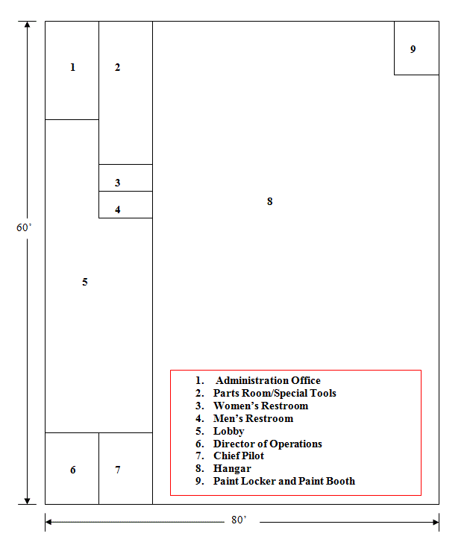

Second Floor

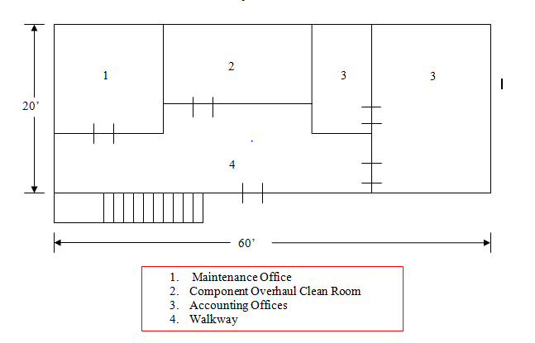

Third Floor

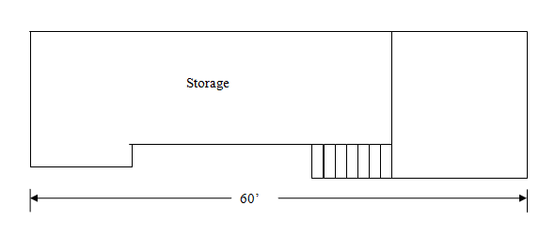

APPENDIX A – FAIRBANKS SATELLITE REPAIR STATION FACILITY

General
The Accountable Manager will ensure MHI maintains the Fairbanks Satellite Repair Station facility for performing the maintenance, preventive maintenance, or alterations of articles or the specialized services for which Homer Part 145 Repair Station is rated, including but not limited to the following:

- Sufficient work space and areas for the proper segregation and protection of articles during all maintenance, preventive maintenance, or alterations.

- Segregated work areas enabling environmentally hazardous or sensitive operations such as painting, cleaning, welding, avionics work, electronic work, and machining to be done properly and in a manner that does not adversely affect other maintenance or alteration articles or activities.

- Suitable racks, hoists, trays, stands, and other segregation means for the storage and protection of all articles undergoing maintenance, preventive maintenance, or alterations.

- Space sufficient to segregate articles and materials stocked for installation from those articles undergoing maintenance, preventive maintenance, or alterations.

In accordance with 14 CFR §145.105(b), MHI will not make any changes to its housing or facilities required by 14 CFR §145.103 that could have a significant effect on its ability to perform the maintenance, preventive maintenance, or alterations under its temporary approval without written notice to the FAA.

The Accountable Manager shall be responsible for notifying the FAA if changes to housing or facilities are anticipated for approval.

In accordance with 14 CFR §145.223, MHI shall allow the Administrator to inspect the MHI Repair Station and its temporary facilities at any time.

  - Description of Fairbanks Housing and Facilities

The Maritime Helicopters Fairbanks Satellite Repair Station is housed in two buildings located at Metro Field, 1915 Donald Avenue, Fairbanks, Alaska. Application for changes in location or in housing and facilities shall be made by the Accountable Manager. Approval to perform any temporary maintenance shall be requested in writing and approval received in writing from the Anchorage CHDO before conducting such maintenance.

MHI Fairbanks maintains separation and positive control of incoming materials and their respective storage. Green tagged parts and parts that have not gone through the receiving inspection are quarantined in a locked cage in the parts room. Parts are inspected and received at a desk located next to the locked cage. The Parts Room is located upstairs from the hangar floor and has suitable racks/bins for the organization and storage of material used by MHI. Additional storage areas are located in the hangar areas for expendable floor-stock, with flammables stored in approved cabinets

The main hangar is of wood frame construction, 80’ wide and 112’ long on a concrete pad. The ceiling is 18’ high with six 12’ wide sliding doors on the south side. The hangar is heated by fuel oil fired heater units. HWBB and electrical base board. On the north end of the hangar is located a shop area 32’ by 56’ for the overhaul and paint shop. Parts are stored on the second floor in an area also 32’ by 56’.
  - Main Hangar Floor Plan

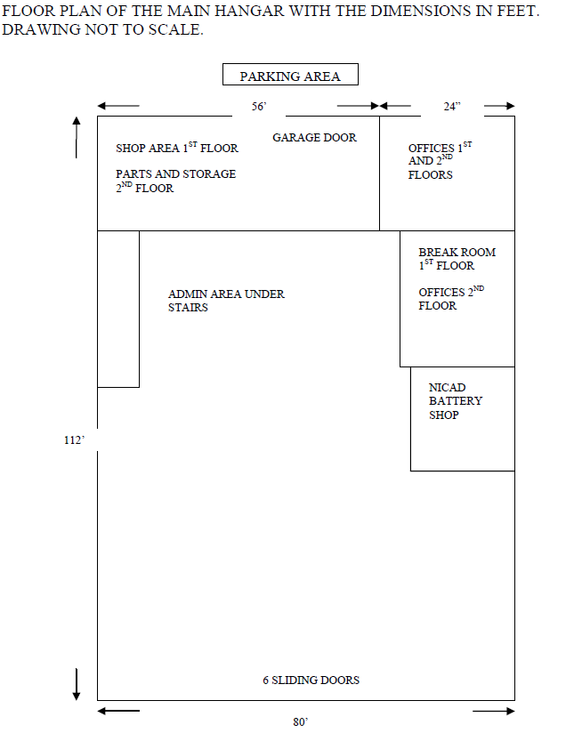

Main Hangar Shop Area Floor Plan

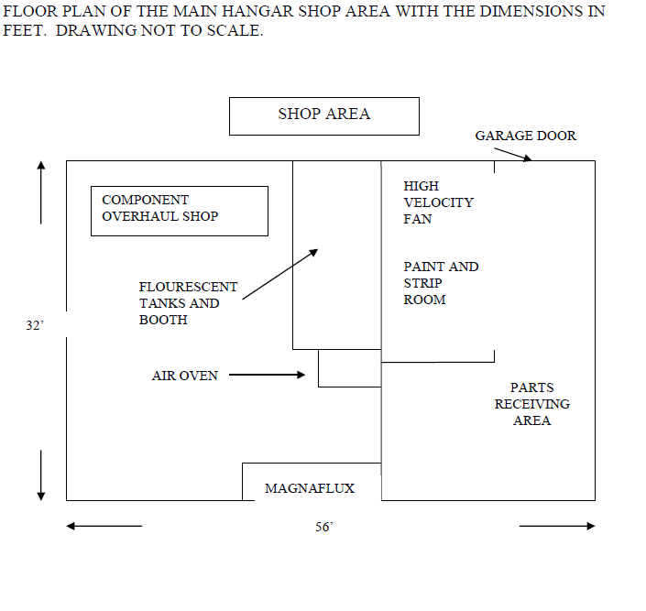

West Hangar Floor Plan
The west hangar is of wood frame construction, 70’ wide and 90’ long on a concrete pad. The ceiling is 15’ high with three 17’ wide sliding doors on the west side. This hangar is also heated by fuel oil fired unit heaters and HWBB. The Avionics Shop (see next page) and Training Room are housed in this west hangar.

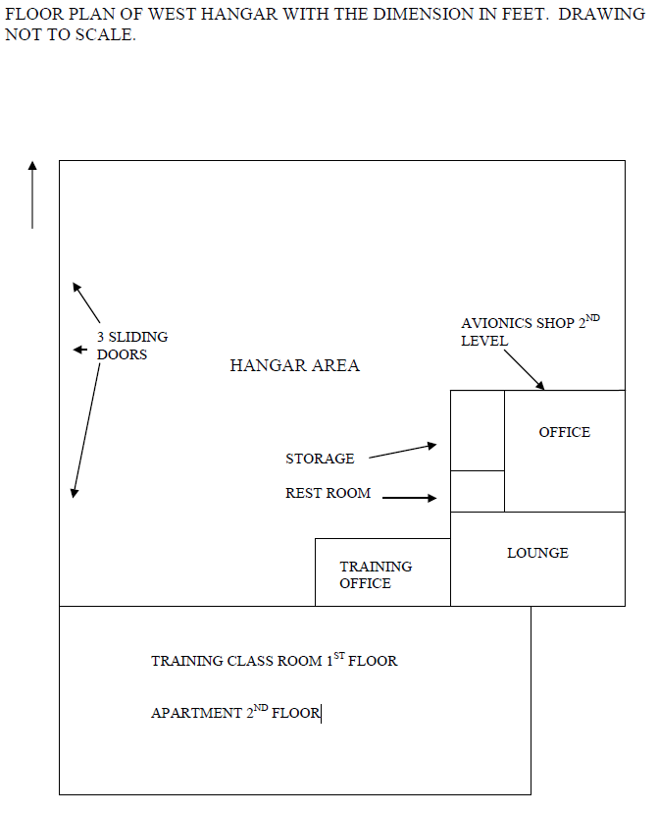

Avionic Shop Area Floor Plan

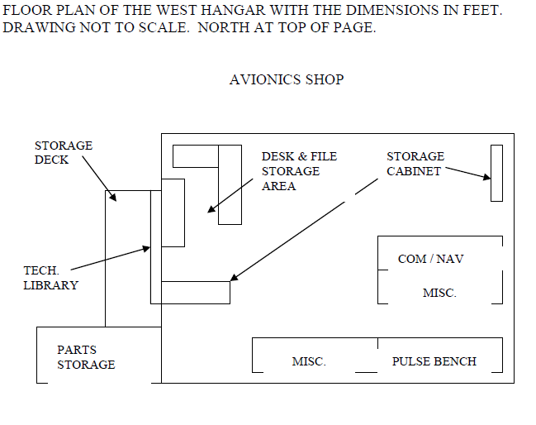

APPENDIX B – Repair Stations Forms

Attached is Appendix A “Repair Stations Forms”

This document has its own List of Effective Pages and Numbering System. No attempt will

be made to included these in the LOEP’s of the Repair Stations Manual.

