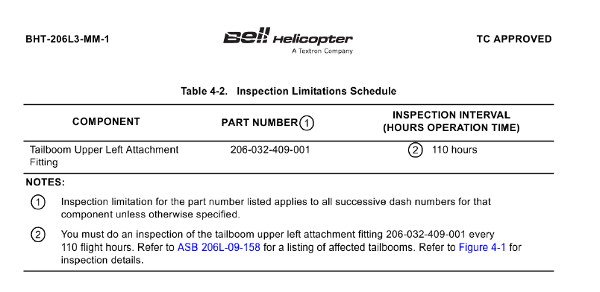
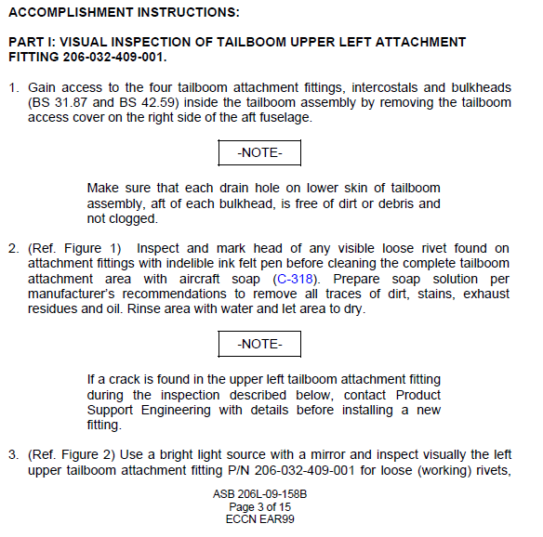

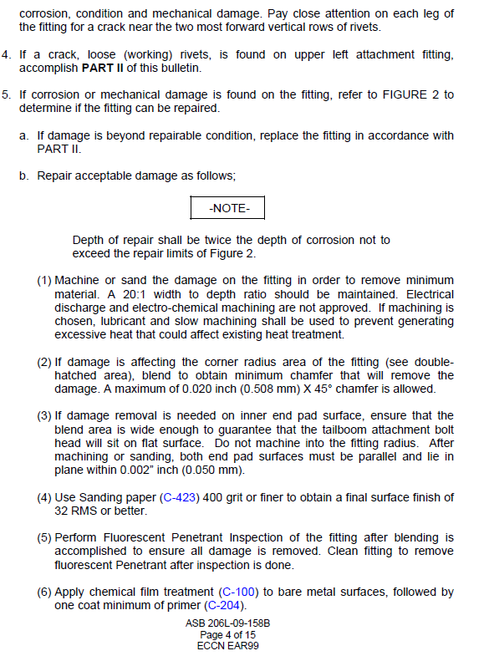
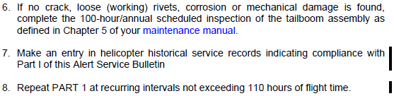

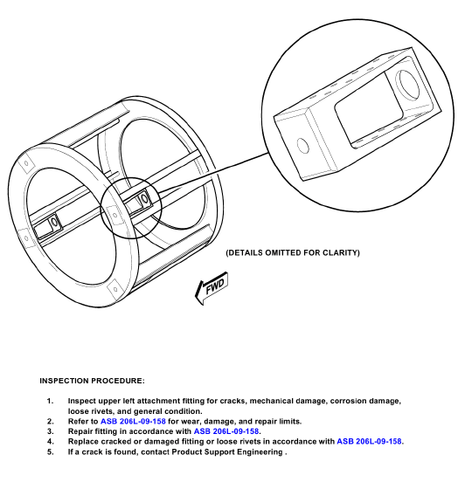

Complied with 100 hr / 12 Mon Tail Boom Inspection ASB 206L-158B Part I. No defects noted.
Signature _____________________________________ Cert# ________________________________
Acft TT _________________________ Date _______________________ WO# __________________

