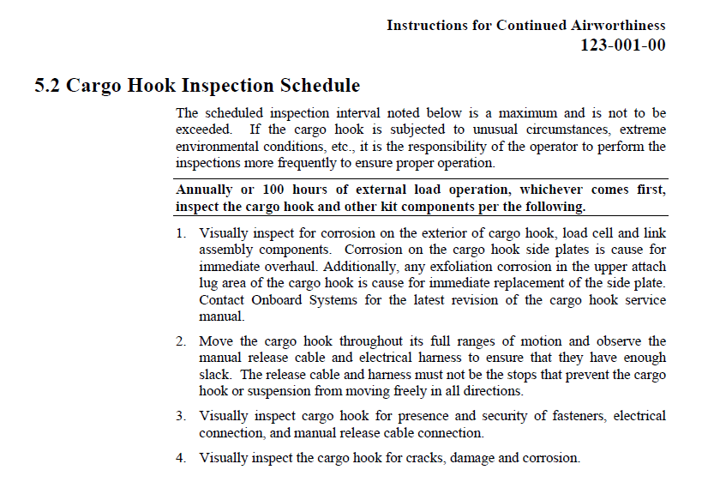

Complied with Onboard Systems 100 hr / 12 Mon Cargo Hook Inspection I/A/W ICA# 123-011-00 Para
5.2. No defects noted. Signature ______________________________ Cert# ____________________
Acft TT _________________________ Date _______________________ WO# __________________

